МИНИСТЕРСТВО ОБРАЗОВАНИЯ И НАУКИ МУРМАНСКОЙ ОБЛАСТИ

ГОСУДАРСТВЕННОЕ АВТОНОМНОЕ ПРОФЕССИОНАЛЬНОЕ ОБРАЗОВАТЕЛЬНОЕ УЧРЕЖДЕНИЕ МУРМАНСКОЙ ОБЛАСТИ
«МУРМАНСКИЙ МЕДИЦИНСКИЙ КОЛЛЕДЖ»
РАБОЧАЯ ТЕТРАДЬ
ПО УЧЕБНОЙ ДИСЦИПЛИНЕ
«АНГЛИЙСКИЙЙ ЯЗЫК»
(для реализации самостоятельной работы)

По специальности: | 34.02.01 Сестринское дело
Курс: | 1-2 курс специальность 34.02.01 Сестринское дело (на базе СОО);  2-3 курс специальность 34.02.01 Сестринское дело (на базе ООО)
УД (МДК, ПМ): | Английский язык
Разработчик (составитель) разработки: | Рачок Антонина Анатольевна, преподаватель ГАПОУ МО «ММК»
Мурманск, 2019
СОДЕРЖАНИЕ

Введение 3
Учебно-тематический план 5
Раздел 1. Вводно-коррективный курс 7
Тема 1.1. Фонетический строй английского языка. Алфавит. Правила чтения и постановки ударения 7
Тема 1.2. Моя биография. Имя существительное 17
Тема 1.3. Моя семья. Мой дом. Местоимение 19
Тема 1.4. Мой родной город. Моя родина. Страна изучаемого языка. Имя существительное. Артикли 22
Тема 1.5. Достопримечательности города. Оборот there is/there are 25
Тема 1.6. Медицинский колледж. Оборот there is/there are 27
Тема 1.7. Учебный процесс в медицинском колледже. Имя прилагательное 29
Тема 1.8. Профессия медицинского работника. Имя прилагательное 31
Раздел 2.анатомия человека 34
Тема 2.1. Анатомическое строение тела человека. Глагол to be в настоящем времени 34
Тема 2.2. Внутренние органы тела. Глагол to be в прошедшем времени 36
Тема 2.3. Скелет человека. Глагол to be в будущем времени. 38
Тема 2.4. Кости скелета. Глагол to be в разных временах. 41
Тема 2.5. Виды мышц и тканей. Глагол to have в настоящем времени 43
Тема 2.6. Кровь и ее элементы. Глагол to have в прошедшем времени 47
Тема 2.7. Сердце. Глагол to have в будущем времени 49
Тема 2.8. Дыхательная система. The present simple tense 52
Тема 2.9. Пищеварительная система. The present continuous tense 56
Раздел 3. История медицины 61
Тема 3.1. История медицины. The present perfect tense 61
Тема 3.2. Ученые-медики и их вклад в медицину. The present perfect tense 64

ВВЕДЕНИЕ

Основная целью обучения иностранному языку – формирование иноязычной коммуникативной компетенции специалиста-медика, позволяющей использовать иностранный язык как средство профессионального и межличностного общения.
Результатом освоения программы учебной дисциплины «Английский язык» является овладение общими (ОК) и профессиональными (ПК) компетенциями:
ОК 1. Понимать сущность и социальную значимость своей будущей профессии, проявлять к ней устойчивый интерес.
ОК 2. Организовывать собственную деятельность, выбирать типовые методы и способы выполнения задач, оценивать их эффективность и качество.
ОК 3. Принимать решения в стандартных и нестандартных ситуациях и нести за них ответственность.
ОК 4. Осуществлять поиск и использование информации, необходимой для эффективного выполнения возложенных на него профессиональных задач, а также для своего профессионального и личностного развития.
ОК 5. Использовать информационно-коммуникационные технологии в профессиональной деятельности.
ОК 6. Работать в коллективе и команде, эффективно общаться с коллегами, руководством, потребителями.
ОК 7. Брать на себя ответственность за работу членов команды (подчиненных), за результат выполнения заданий.
ОК 8. Самостоятельно определять задачи профессионального и личностного развития, заниматься самообразованием, осознанно планировать и осуществлять повышение своей квалификации.
ОК 9. Ориентироваться в условиях частой смены технологий в профессиональной деятельности.
ОК 10. Бережно относиться к историческому наследию и культурным традициям народа, уважать социальные, культурные и религиозные различия.
ОК 11. Быть готовым брать на себя нравственные обязательства по отношению к природе, обществу и человеку.
ОК 12. Организовывать рабочее место с соблюдением требований охраны труда, производственной санитарии, инфекционной и противопожарной безопасности.
ОК 13. Вести здоровый образ жизни, заниматься физической культурой и спортом для укрепления здоровья, достижения жизненных и профессиональных целей.

Курс должен способствовать формированию и развитию профессиональный компетенций (далее – ПК), включающих в себя способность:

ПК 1.1. Проводить мероприятия по сохранению и здоровья населения, пациента и его окружения.
ПК 1.2. Проводить санитарно-гигиеническое воспитание населения.
ПК 1.3. Участвовать в проведении профилактики инфекционных и неинфекционных заболеваний.
ПК 2.1. Представлять информацию в понятном для пациента виде, объяснять ему суть вмешательств.
ПК 2.2. Осуществлять лечебно-диагностические вмешательства, взаимодействуя с участниками лечебного процесса.
ПК 2.3. Сотрудничать с взаимодействующими организациями и службами.
ПК 2.7. Осуществлять реабилитационные мероприятия.
ПК 2.8. Оказывать паллиативную помощь.
ПК 3.1. Оказывать доврачебную помощь при неотложных состояниях и травмах.
ПК 3.2. Участвовать в оказании медицинской помощи при чрезвычайных ситуациях.
ПК 3.3. Взаимодействовать с членами профессиональной бригады и добровольными помощниками в условиях чрезвычайных ситуациях.

В результате освоения дисциплины обучающийся должен уметь:

- в результате освоения дисциплины обучающийся должен уметь:
- общаться устно и письменно на иностранном языке на профессиональные и повседневные темы;
- переводить со словарем иностранные тексты профессиональной направленности;
- самостоятельно совершенствовать устную и письменную речь, пополнять словарный запас

- в результате освоения дисциплины обучающийся должен знать:
- лексический (1200 - 1400 лексических единиц) и грамматический минимум, необходимый для чтения и перевода со словарем иностранных текстов профессиональной направленности.

Рабочая тетрадь предназначена для подготовки к практическим занятиям студентов по специальности 34.02.01 Сестринское дело
Требования, как и результаты процесса, определяются преподавателем в соответствии с ФГОС и рабочей программой учебной дисциплины. Для достижения желаемых результатов требуется организация самостоятельной работы студентов и эффективный контроль.
Рабочая тетрадь содержит введение и основную часть с комплексом многофункциональных упражнений, направленных на закрепление полученных теоретических знаний.
Материал упражнений соотносится с основными разделами курса «Вводно – коррективный курс», «Анатомия человека», «История медицины», «Здоровый образ жизни». Задания расположены по мере возрастания трудностей, что позволяет провести ранжирование заданий в зависимости от индивидуальных и групповых особенностей студентов, сосредоточиться на заданиях, требующих автоматизации определенных языковых навыков.
Рабочая тетрадь включает в себя упражнения по темам: правила чтения и постановки ударения, имя существительное, имя прилагательное, образование множественного числа, сложные и простые клинические термины, предлоги, артикли.

УЧЕБНО-ТЕМАТИЧЕСКИЙ ПЛАН

№ п/п | Название темы | Количество часов СР (очная форма) | Вид работы
РАЗДЕЛ 1. ВВОДНО-КОРРЕКТИВНЫЙ КУРС
 | Тема 1.1. Фонетический строй английского языка. Алфавит. Правила чтения и постановки ударения | 2 | чтение и перевод текста;  отвечают на вопросы;  поиск эквивалентов в тексте; выполнение грамматических упражнений
 | Тема 1.2. Моя биография. Имя существительное | 1
 | Тема 1.3. Моя семья. Мой дом. Местоимение | 1
 | Тема 1.4. Мой родной город. Моя родина. Страна изучаемого языка. Имя существительное. Артикли | 1
 | Тема 1.5. Достопримечательности города. Оборот there is/there are | 1
 | Тема 1.6. Медицинский колледж. Оборот there is/there are | 1
 | Тема 1.7. Учебный процесс в медицинском колледже. Имя прилагательное | 1
 | Тема 1.8. Профессия медицинского работника. Имя прилагательное | 2
РАЗДЕЛ 2.АНАТОМИЯ ЧЕЛОВЕКА
 | Тема 2.1. Анатомическое строение тела человека. Глагол to be в настоящем времени | 2 | чтение и перевод текста;  отвечают на вопросы;  поиск эквивалентов в тексте; выполнение грамматических упражнений
 | Тема 2.2. Внутренние органы тела. Глагол to be в прошедшем времени | 2
 | Тема 2.3. Скелет человека. Глагол to be в будущем времени. | 2
 | Тема 2.4. Кости скелета. Глагол to be в разных временах. | 2
 | Тема 2.5. Виды мышц и тканей. Глагол to have в настоящем времени | 2
 | Тема 2.6. Кровь и ее элементы. Глагол to have в прошедшем времени | 2
 | Тема 2.7. Сердце. Глагол to have в будущем времени | 2
 | Тема 2.8. Дыхательная система. The present simple tense | 2
 | Тема 2.9. Пищеварительная система. The present continuous tense | 2
РАЗДЕЛ 3. ИСТОРИЯ МЕДИЦИНЫ
 | Тема 3.1. История медицины. The present perfect tense | 1 | чтение и перевод текста;  отвечают на вопросы;  поиск эквивалентов в тексте; выполнение грамматических упражнений
 | Тема 3.2. Ученые-медики и их вклад в медицину. The present persect tense | 1
 | ИТОГО: | 30

РАЗДЕЛ 1. ВВОДНО-КОРРЕКТИВНЫЙ КУРС

ТЕМА 1.1. ФОНЕТИЧЕСКИЙ СТРОЙ АНГЛИЙСКОГО ЯЗЫКА. АЛФАВИТ. ПРАВИЛА ЧТЕНИЯ И ПОСТАНОВКИ УДАРЕНИЯ

Студент должен знать:
-Алфавит;
-Правила чтения букв и буквосочетаний;
-Правила постановки ударения в односложных и многосложных словах.

Студент должен уметь:
-Читать слова и словосочетания, согласно правилам чтения и постановки ударения.

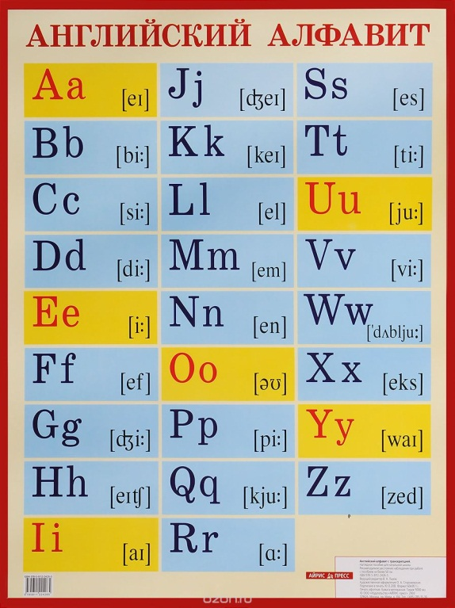
Как правильно произносить алфавит? Транскрипция — это запись звучания буквы или слова в виде последовательности специальных фонетических символов. Зная транскрипцию, вы без посторонней помощи правильно прочитаете незнакомое слово. Транскрипция напрямую связана с правилами чтения.

Транскрипционные значки и их произношение
Правила чтения гласных букв в английском языке
В английском языке гласные буквы многозначны. В алфавите всего шесть гласных букв: a [ei], e [i:], i [ai], о [ou], u [ju:] и y [wai],но с их помощью отражают двадцать четыре гласных звука.
Чтение гласных можно условно разбить на две категории: ударные гласные и безударные.
Правила произношения ударных:
1. В открытом (go) или условно открытом (polea) слоге гласные читаются так же, как и называются в алфавите.
2. В закрытом слоге гласные передают краткие звуки.
3. Когда после гласной стоит буква «r» или «r» и согласная, то произносится долгий звук.
4. Когда после гласной стоит «re» или «r» и гласная, то она читается как трифтонг или дифтонг.
5. Наиболее понятно эти правила вам продемонстрирует данная таблица:
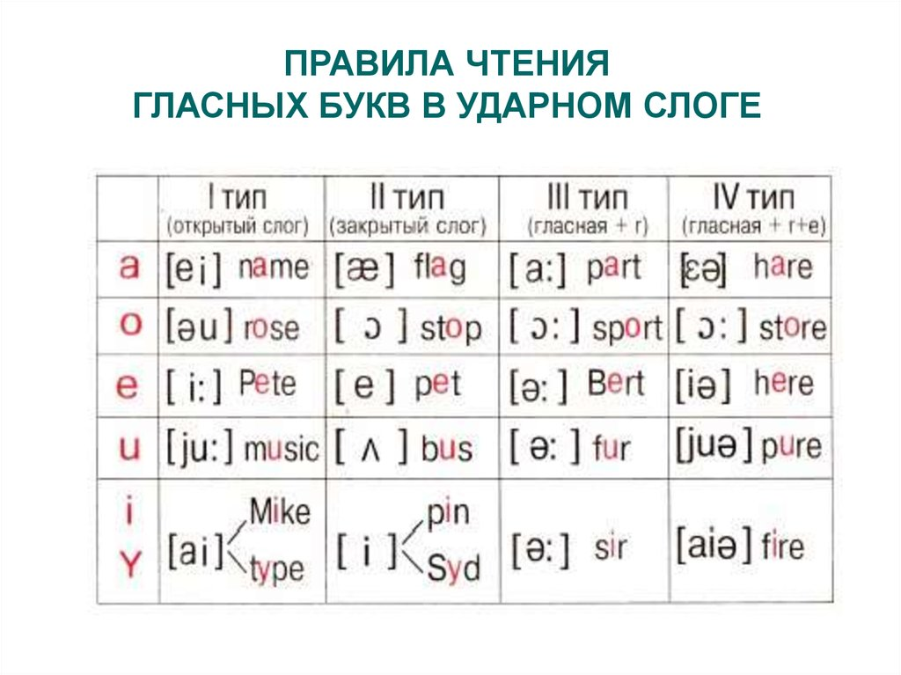
Правила произношения безударных

1. Буквы “e”, “y”, “i” произносятся как [i], если после них не стоит “r”: divide [di′vaid].
2. Гласные “a”, “u”, “o” без ударения, а также в префиксах и суффиксах читаются как звук [ə]:
glorious [glo:riəs].
3. Буква “i” перед гласной произносится как [j]: union [′ju:njən].
4. Гласные перед “r” передают звук [ə]: player [`pleiə(r)].

Чтение гласных буквоcочетаний

oo [u] look, book, cook, good, foot
[u:] pool, school, Zoo, too
ee [i:] see, bee, tree, three, meet
ea [i:] tea, meet, eat, read, speak, clean, please
BUT: [e] bread, head, breakfast, healthy
au [ei] away, play, say, may, today
ey grey, they

Чтение согласных буквосочетаний

ck [k] black, stick
ng [ŋ] sing, bring, ring, reading
sh [∫] she, shop, fish
ph [f] phone, photograph
[v] nephew
th
[ð] this, that, the
[θ] thank, thick
[t] Thames
wh [w] when, white, why BUT: [h] Who kn [n] know, knife wr [r] write, wrong gh [f] enough [–] high

Чтение букв С и G перед гласными e, i, y

c [s] city, pencil, nice
g [dG] large, orange, page

Фонетические упражнения
Упражнения по чтению гласных в ударных типах слога I i – [αı]

1. Прочитайте!
[αı] [ı] [αı] [ı]
hi tip white bit
pine thin nine bin
like chick five lip
fine six write bill
nice milk wife chips
tie big size dish
time winter ride film
mine spring pipe in
kite little slice his

- Выберите и прочитайте слова открытого типа слога, а затем закрытого:
Side, smile, bring, pile, disc, slide, his, mix, king, mice, bike, fish, dinner, fit, pie, pipe, pink, mile, chin, fill, pig, him, hip, ink, life, if.

- Прочитайте и напишите следующие слова:
[smαıl] [klαım] [slim]
[tαım] [hip] [fi ∫]
[t∫ın] [sprıŋ] [fαın]
[θık] [wαıf] [kıŋ]
[΄dınə] [nαın] [sαıd]
[pαıl] [hız] [mıks]

- Напишите транскрипцию следующих слов:
Side, pine, write, size, dish, chips, pie, disc, tie, thin, white, milk, little, pipe, six, fill, fish, bike.

- Прочитайте:
Nick has a fine kite.
Pete has five pink pigs and nine chicks.
I like milk and pie.
Mike likes to ride a bike.
His fish is thin and his stick is thick.
Bill likes winter and spring.
Hi, I am fine.
I like to drink milk for dinner.
Bring five, six or nine dishes with chips.

A a – [eı]
- Прочитайте:
[ eı ] [ æ ] [ eı ] [ æ ]
make plan label at
take bad came as
snake stand age bank
tape lamp date back
name fact face camp
place add shape catch
made bad hate damp
plate can plane glad
same cap wage jam

2. Выберите и прочтите слова открытого слога, а затем закрытого:
back, hand, face, paper, apple, table, map, cat, flat, bag, cake, late, game, flag, rat, rate, lake, man, wave.

3. Прочитайте и напишите следующие слова:
[ læmp ] [ sneık ] [∫eıp ]
[ teıbl ] [ neım ] [ heıt ]
[ keıt ] [ teık ] [ kæn ]
[ ræbit ] [ flag ] [ plæn ]
[ kæmp ] [ mæp ] [æz ]

4. Напишите транскрипцию следующих слов:
make, plate, face, wage, can, stand, bank, catch, cake, made, damp, jam.

5. Прочитайте:
A fat cat sat on a mat and had a black rat.
Pat has a cat and a hat.
Kate, take a plate.
Sam hates apples.
Lamp stands on the table.
Make the same cake.
Catch the bad rat.
I am glad of plate of jam.

E e – [ı:]
1. Прочитайте:
[ı:] [e[ [ı:] [e]
he let green text
she met three leg
we red feet left
see bed tea pet
bee hen eat yes
meet ten teacher mend
Pete shelf peach then
need then meat neck
week pen read rest
tree men season desk
breed dress sheep fed

2.Выберите и прочитайте слова сначала со звуком [ı:], а затем со звуком [e]:
Clean, felt, please, street, fence, next, press, get, been, bell, best, chess, deep, end, geese, steel, smell, deep, agree, kept, get, well, team, tell, went, wheel

3. Прочитайте и напишите следующие слова:
[sı:] [tekst] [pen]
[mı:] [rı:d] [wı:k]
[men] [stı:l] [mes]
[∫ı:p] [step] [nek]
[klı:n] [ðen] [sı:zn]

4. Напишите следующие слова в транскрипции:
Fence, next, hen, Pete, bee, three, then, melt, read, feet, steel, sheep, bed, men, yes, leg, rest

5. Прочитайте:
We fed Pete’s three pets.
I met ten men in the street.
I like cheese, tea, meat and peaches.
She left pencils, pens and the text on the desk.
I see a bee in a tree.
He reads texts very well.
I need my red dress.

O o – [əu]
1. Прочитайте!
[əu] [o] [əu] [o]
rose stop hope shop
nose clock home log
tone on smoke pot
bone box phone spot
over hot alone got
sofa shot close top
those dog coal bottle
go frog hope bomb
open wrong cock

2. Выберите и прочитайте слова открытого типа слога, а затем закрытого:
off, ocean, office, lot, scone, hole, hobby, hotel, post, song, pop, soft, doll, golf, hope, tone, sock, stove, whole, wrong.

3. Прочитайте и напишите следующие слова:
[nəuz] [ləun] [botl]
[skəun] [∫ot] [həum]
[΄ofis] [΄əupən] [fəun]
[soft] [gəu] [got]
[stəun] [rəuz] [lot]

4. Напишите транскрипцию следующих слов:
Home, rose, wrong, close, stop, cock, those, go, tone, frog, box, phone, over, hobby, stove, post.

5. Прочитайте
Don’t go home alone!
Hot potato, cold pot.
The dog sits on the old soft sofa.
Those scones are hot I hope.
The hotel is open.
I phone wrong.
The frog is on the log.

Uu – [ju:]
- Прочитайте:
[ju;] [Λ] [u(:)] [Λ]
use cut ruler must
tune bus put run
suit us pull such
tube sun push rub
pupil much true supper
tulip gum glue but
due hunt blue gun
cue fun truth duck
few under full drunk
unite current fruit hurry
duty publish June jump

- Прочтите слова сначала со звуком [iu:], затем [u], [Λ]:
lunch, just, luck, music, Tuesday, true, union, hut, rung, unite, summer, fruit, cute, uniform, human, up, shut, full, university, mute, tune

3. Найдите эквиваленты словам, данным в транскрипции:
[`ju:nifo:m], [l Λnt∫], [glu:], [mju:zik], [∫Λt], dju:tı], [`kΛrənt], tru:θ], [gΛm], [tju:lıp], [pju:pl],
[ju:`nαıt], [d3Λmp], [kΛt], [sju:t]
______________________________________________________________________
unite, lunch, music, jump, truth, gum, glue, uniform, shut, duty, pupil, current, cut, tulip, suit

4. Запишите следующие слова в транскрипции:
Tube, sun, true, rubber, but, cue, hunt, publish, much, under, push, put, duck, but.

5.Прочитайте:
I like fruit juice very much.
Pupils use a ruler and a rubber.
He hunts with a gun.
Susan has a blue cup.
I must run and jump.
She puts a suit or a uniform.
Students must study at the university.

Yy - [wαı]
- Прочитайте:
[αı] [ı] [j] [ı]
sky study yellow gym
my only yet gyps
fly any yes mystic
type city yelp lynch
cycle many yard dynamics
rhyme lorry yield dynamite
why sorry yell cylinder
shy very yolk pyramid
by sunny year cryptic
try

2. Выберите и прочтите слова открытого типа слога, затем закрытого:
hype, lye, myth, lynch, byte, dye, hysterics, rye, sly, mystic, cryptic, typical, gym

3. Выберите слова, где “y” читается как [ı], затем как [j].
party, simply, yelp, yummy, yolk, study, yesterday, young, only, happy, yap, yes, tidy, youth, mummy.

4. Напишите следующие слова в транскрипции:
My, any, yet, yelper, dying, lynch, mystic, cry, sorry, mystify, byte, cyclist, rye, only, sunny.

5. Прочитайте и напишите следующие слова:
[jes], [`stΛdı], [d3u`lαı], [hαıp], [`hæpı], [mıθ], [trαı], [wαı], [`beıbı], [`pΛpı],[jo:k], [jelp], [`menı], [tαık], [`tıpıkəl], [sαıkl], [jo:], [dαı], [`pırəmıd]

6. Прочитайте:
Yes, the yolk is yellow yet.

Butterfly, butterfly, where do you fly?
I fly in the sky.

Little baby often cry.
Sorry, my cycle doesn’t work.
We yield much rue this year.
We study physics on Friday.
On my birthday party was sunny.

Третий тип слога: a+r, o+r, i+r, u+r, e+r

1. Прочитайте:
[α:] [o:] [ə:] [ə:]
car for her turn
star storm term fur
far fork per burn
harm forty nerve nurse
barn corn advertise suburb
charm force person surname
arm born fertile turner
mark pork skirt curds
march horse shirt curtain
sharp import bird church
dark order first curve

2. Прочитайте сначала слова со звуком [α:], [o:], затем со звуком [ə:]:
short, garden, dirt, German, burglar, pork, scarf, merchant, worn, bar, large, internal, herself, hard, inform, export, art, farm, circle, card, carpet, horn

3. Напишите следующие слова в транскрипции:
Storm, fork, pork, herd, further, garden, vortex, merchant, torn, charm, orchard, furnish, target, party, smart, third, surname

4. Прочитайте и напишите следующие слова:
[k α:], [m α:k], [θ ə:d], [ko:n], [`t ə:n ə], [n ə:s], [fo:s], [spo:t], [wo:n], [fə:m], [∫ə:t], [fə:], [`o:də], [bα:n]

5.Прочитайте:
It is dark in the park.
They buy a car for the farm this morning.
She has a turkey and a bird.
We import hard sort of corn.
In our town there are many churches and orchards and one circus.
On Thursday is my birthday party.
There is a large carpet on the floor.

4-й тип слога
гласная + r + гласная, гласная + гласная + r

1. Прочитайте:
a+r+e [ε ə] i+r+e [aıə] e+r+e [ıə] y+r+e [ αıə]
bare tire here tyre
hare hire mere byre
mare fire sphere
care dire
rare admire
dare wire
entire
expire
retire

ai+r [ε ə] ee+r [ıə] ea+r [ıə] ea+r [ε ə]
chair deer tear wear
hair veer clear pear
fair cheer ear swear
steer fear rear

o+r+e [o:] u+r+e [ju:ə] oo+r, ou+r, oa+r [o:]
bore pure door
more indure floor
fore adjure four
shore cure course
store allure source
swore bureau board
core endure uproar
adore epicure

- Прочитайте:
pare, chair, tire, entire, here, fear, fair, tyre, pure, bore, dire, veer, dare, tear, shore, door, cure, clear, flare, ear, board, four, soar, source, square, pore, indure, allure

3. Подберите транскрипцию к следующим словам:
chair [mo:] pure [flo:]
mare [fεə] desire [ıə]
pare [t∫ıə] tyre [w aıə]
fire [mεə] endure [pju:ə]
fare [stıə] floor [taıə]
more [faıə] swear [dı`zaıə]
steer [t∫εə] wire [ən`dju:ə]
cheer [pεə] ear [swεə]

4. Выберите из предложенных слов слова 4 типа слога и прочтите их:
Turn, board, merchant, church, fair, epicure, source, uproar, desire, hare, bare, retire, wire, hurt, mark, stork, herself, core, byre.

5. Прочитайте:
There is a bare on the chair.
She has fair hair and small ears.
I poured some more pure pear juice.
The armchair is here near the fireplace.
Clare, take care! Here is the hare.
There are four doors on the second floor.

ТЕМА 1.2. МОЯ БИОГРАФИЯ. ИМЯ СУЩЕСТВИТЕЛЬНОЕ

Глоссарий:
to introduce myself – представиться
communicable – общительный
friendly – дружелюбная
nurse – медсестра
to describe – описать
appearance – внешность
slim – стройный
dark – темный
spare time – свободное время
to chat – общаться
exact sciences – точные науки
qualified – квалифицированный

1. Прочитайте и переведите текст.
Hello! Let me introduce myself. My name is Maria. My surname is Petrova. I was born on the 10th of August in Moskow. This is the most beautiful city on the Earth. Moskow is the capital of Russia. I am 18 years old. I am a first-year student at the medical college. In 3 years I’ll be a nurse.
Now I want to describe my appearance. I am tall and slim. I have dark hair and green eyes. I am communicable and friendly. I have many friends. My hobby is art. I like drawing portraits and seascapes. I have many paintings in my collection. Also I go in for swimming. I like playing football very much.
In my spare time I prefer reading and chatting on-line with my friends. When the weather is fine I like walking in the park with my friends. We often visit museums, art galleries and theatres. I like art very much. I read a lot of books on art, history and science. I like exact sciences, especially chemistry and physics. I often watch Discovery and Science channels on TV. Now I am a student. I want to learn hard to become qualified specialist.

2. Ответьте на вопросы.
1. Where and when Maria was born?
2. What is Maria’s occupation?
3. How old is Maria?
4. What is her appearance like?
5. What is her character like?
6. What is her hobby?
7. What does she like doing in spare time?
8. What places does she visit?
9. What other preferences (предпочтения) does she have?
10. Why does she want to learn hard?

3. Переведите словосочетания с русского на английский язык.
Позвольте представиться, родилась, самый красивый город на Земле, студент первого курса, через 3 года, описать свою внешность, общительная и дружелюбная, заниматься плаванием, в мое свободное время, общаться в интернете, книги об искусстве и науке, точные науки, усердно учиться, квалифицированный специалист.

4. Расскажите о себе, используя следующие фразы.
1. Let me … .
2. My name is … . My surname is … .
3. I was born on the … in … .
4. I am … (age).
5. I am a … (occupation).
6. My hobby is … .
7. In my spare time I … .
8. I like to visit … .
9. I like to read … .
10. My favourite subject(s) is (are) … .
11. I often watch … on TV.
12. When I graduate from the college (institute) … . I will be …

Образование множественного числа существительных в английском языке (Plural of Nouns)

1. Образуйте множественное число.

a. diary –
f. baby –
b. sheep –
g. key –
c. book –
h. match –
d. cherry –
i. bus –
e. fish –
j. watch –

2. Напишите во множественном числе существительные исключения.

a. woman –
e. man –
b. mouse –
f. child –
c. tooth –
g. goose –
d. foot –
h. ox –

3. Образуйте множественное число, обращая внимание на употребление артиклей.
A baby, a plant, a lemon, a peach, a banana, a brush, a star, a mountain, a tree, a shilling, a king, the waiter, the queen, a man, the man, a woman, the woman, an eye, a shelf, a box, the city, a boy, a goose, the watch, a mouse, a dress, a toy, the sheep, a tooth, a child, the ox, a deer, the life, a tomato, a secretary, a crowd, the airport, a theatre, the tornado, a shop, the tragedy.

ТЕМА 1.3. МОЯ СЕМЬЯ. МОЙ ДОМ. МЕСТОИМЕНИЕ

Глоссарий:

mother (mum, mom, mummy)
father (dad, daddy)
husband
wife
aunt
uncle
cousin
grandfather (granddad)
grandmother (granny, grandma)
grandson
niece
nephew
twins
daughter-in-law
son-in-law
sister-in-law
brother-in-law
mother-in-law
father-in-law
relative
stepmother, stepfather
Godfather, Godmother

- Прочитайте и переведите текст.
I would like to tell you about my family. It is very large and I am proud of it. We are seven: mother, father, two brothers, grandmother and grandfather who are my mothers parents.
I am seventeen. My elder brother is twenty, he is in the army now. My younger brother is a schoolboy, he is twelve. I love my brothers very much, we are great friends and always help each other.
My father is a worker at a car plant. He works five days a week and he likes his job. He often tells us interesting things about the cars they make.
My mother is a nurse at a hospital. She has a lot of work to do there and sometimes she stays there at night. When she has free time, she goes to the swimming pool.
As mother always busy at work, our grandmother keeps the house. She cooks our meals and we help her to wash up, to clean the rooms, and grandfather does the shopping. Our grandfather is not very old, he is sixty-five and he still works three days a week. He is full of energy and says work keeps him healthy and young.
In the evening when everybody is at home, we like to stay in our big sitting room together. Grandfather reads a book, grandmother knits and father helps my younger brother to do his lessons. I write a letter to my elder brother and draw pictures of all the members of my family, including our dog and cat. Our dog is my younger brothers pet. He takes her out for a walk in the mornings and in the evenings.

- Ответьте на вопросы.
- How many members are there in the family?
- How old is the author?
- Who are the authors brothers?
- What is the profession of the mother?
- Where does her father work?
- Where does her mother go when she has free time?
- Who keeps the house?
- What does granny do about the house?
- How old is the grandfather?
- What do the grandparents do in the evening?
- Составьте историю о своей семье.
- My name is…
- I am (16 – sixteen)
- I am a student of Murmansk medical college.
- I like to (listen to music, surf the Internet, play computer games, go info sports).
- My hobby is (drawing).
- I don’t like to (read books…)
- My parents are always busy.
- My mothers (fathers, brothers) name is…
- We like to (travel, watch movies) when we have free time.

- Составьте и нарисуйте генеалогическое древо своей семьи. Подготовьтесь к его описанию.

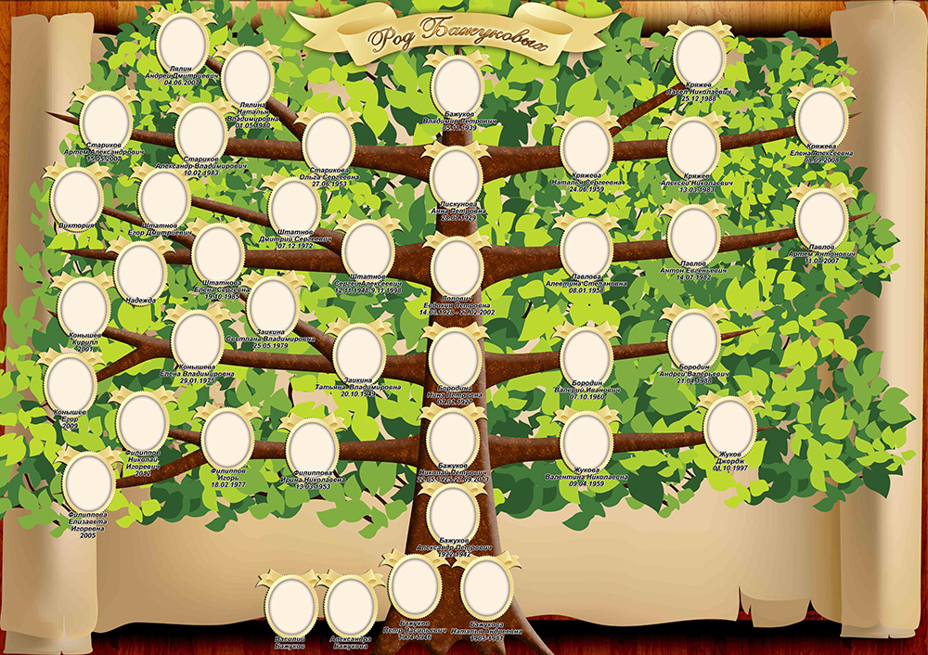

Разряды местоимений

1. Употребите подходящее по смыслу притяжательное местоимение.
1) my 2) your 3) his 4) her 5) its 6) our 7) their
1. Mr. and Mrs. Brown have two children. Both ... children are boys.
2. Miss Smith is a teacher. ... students are Germans.
3. We are French. ... friends are English.
4.You are in Bristol, but ... family is in York.
5. I have a small cat. ... cat is very funny.
6. My daughter has a dog. ... nose is long.
7. My friends have a new car. ... car is very nice.

2. Вставьте личные или притяжательные местоимения в правильной форме.
1. The girls are here, ... came early.
1) I 3) he 5) they 7) me 9) him
2) you 4) she 6) we 8) her 10) them
2. Jane is ... sister, ... is older than ... am.
1) I 3) he 5) they 7) your 9) her
2) you 4) she 6) my 8) his 10) our
3. I invite her to a party at ... place. ... hope ... will bring ... husband with her.
1) I 3) he 5) they 7) his 9) him
2) you 4) she 6) my 8) her 10) me
4. ... like to visit ... friends.
1) I 3) he 5) your 7) her
2) you 4) she 6) my 8) his
5. Mary and ... cousin are spending ... holidays in Brighton.
1) I 3) he 5) they 7) his 9) our
2) you 4) she 6) my 8) her 10) their
6. I don’t hear them. ... are far from me.
1) She 2) You 3) They 4) We 5) Their
7. When Roger saw Ann ... spoke to ... .
1) his 2) he 3) her 4) him
8. The boys left an hour ago. I didn’t see ... .
1) they 2) their 3) them 4) his 5) him

3. Укажите, как правильно перевести подчеркнутые местоимения.
1. Мне нравится твоя куртка. — ..., ...
1) Me 2) I 3) My 4) your 5) you
2. У него есть твой адрес? — ..., ...
1) he 2) his 3) him 4) you 5) your
3. Твоя книга в нашем шкафу. — ..., ...
1) you 2) your 3) we 4) our 5) us
4. Им понравился их новый дом? — ..., ...
1) their 2) them 3) they
5. В тот вечер на ней было голубое платье. — ...
1) her 2) she
6. Моя старая машина сейчас у них в гараже. — ..., ...
1) me 2) my 3) their 4) I 5) them 6) they
7. В субботу они пригласили нас на дачу. — ..., ...
1) us 2) they 3) we 4) our 5) them
8. Завтра у меня день рождения. — ...
1) me 2) I 3) my
9. Им не понравилась его новая девушка. — ..., ...
1) they 2) them 3) their 4) he 5) him 6) his

ТЕМА 1.4. МОЙ РОДНОЙ ГОРОД. МОЯ РОДИНА. СТРАНА ИЗУЧАЕМОГО ЯЗЫКА. ИМЯ СУЩЕСТВИТЕЛЬНОЕ. АРТИКЛИ

Глоссарий
is situated – расположена
to border on –граничить с
variety – разнообразие
climate conditions – климатические условия
different – различный
ferrous (non-ferrous) metals – черные (цветные) металлы
branch – отрасль, ветвь
mining – горнодобывающая
food processing – переработка продуктов питания
government – правительство
legislative – законодательная
executive – исполнительная
judicial – судебная

- Прочитайте и переведите текст.

The Russian Federation is the largest country in the world. The country is situated in Eastern Europe, Northern and Central Asia. Its total territory is over 17 mln square km. Our land is washed by 12 seas which are the seas of three oceans: the Arctic, the Atlantic and the Pacific. Russia borders on 14 countries, it is also has a sea – border with the USA.
Our country has a great variety of flora and fauna. The highest mountains in our land are the Altai, the Urals and the Caucasus. There are over 2 thousand rivers in Russia. The longest are the Volga, The Yenisei, the Don, the Lena and others.
On the Russian territory there are 11 time zones. The climate conditions are different. Our country is rich in natural resources: oil, natural gas, coal, ferrous and non- ferrous metals and other minerals. Russia is a developed industrial and agricultural country. The main branches of industry are machine-building, chemical, mining, food processing and some others.
The Russian Federation is a multinational state. The population of the country is about 140 mln people. Moskow is the capital of our Motherland. It is the largest political, scientific, cultural and industrial center and one of the most beautiful cities in the world. The Russian Federation is a constitutional state headed by the President. The country government consists of 3 brunches: legislative, executive and judicial.

- Ответьте на вопросы по содержанию текста.
- Where is the Russian Federation situated?
- How many seas and oceans are there in the Russian Federation?
- What are the highest mountains in our land?
- What are the main branches of industry?
- How many people do live in our country?
- Who is the head of the Russian Federation?
- What are the three branches of country government?

- Переведите словосочетания на английский язык.
Страна расположена, Россия граничит с, морская граница, большое разнообразие, часовые пояса, натуральные ресурсы, промышленная и сельскохозяйственная страна, главные отрасли, многонациональное государство, возглавляемое президентом.

- Подготовьте устную тему «Our republic».

- Прочитайте и переведите текст.

Great Britain
The full name of the country the United Kingdom of Great Britain and Northern Ireland. The United Kingdom is situated on the British Isles. The British Isles consist of two large islands, Great Britain and Ireland, and a great number of small islands. Their total area is over 314 000 sq. km. The British Isles are separated from the European continent by the North Sea and the English Channel. Thewestern coast of Great Britain is washed by the Atlantic Ocean and the Irish Sea. Northern Ireland occupies one third of the island of Ireland. It borders on the Irish Republic in the south. The island of Great Britain consists of three main parts: England (the southern and middle part of the island), Wales (a mountainous peninsula in the West) and Scotland (the northern part of the island). There are no high mountains in Great Britain. In the north the Cheviots separate England from Scotland, the Pennines stretch down North England along its middle, the Cambrian mountains occupy the greater part of Wales and the Highlands of Scotland are the tallest of the British mountains. There is very little flat country except in the region known as East Anglia. Most of the rivers flow into the North Sea. The Thames is the deepest and the longest of the British rivers. Some of the British greatest ports are situated in the estuaries of the Thames,Mersey, Trent, Tyne, Clyde and Bristol Avon. Great Britain is not very rich in mineral resources, it has some deposits of coal and iron ore and vast deposits of oil and gas that were discovered in the North Sea. The warm currents of the Atlantic Ocean influence the climate of Great Britain. Winters are not severely cold and summers are rarely hot. The population of the United Kingdom is over 58 million people. The main nationalities are: English, Welsh, Scottish and Irish. In Great Britain there are a lot of immigrants from former British Asian and African colonies.Great Britain is a highly industrialized country. New industries have been developed in the last three decades. The main industrial centres are London, Birmingham, Manchester, Leeds, Liverpool, Glasgow and Bristol. The capital of the country is London. The United Kingdom is a.parliamentary monarchy.

- Ответьте на вопросы.
1. Where is the United Kingdom situated
2. What islands do the British Isles consist of?
3. What ocean and seas are the British Isles washed by?
4. How many parts does the Island of Great Britain consist of and what are they called?
5. What country does Northern Ireland border on?
6. Are there any high mountains in Great Britain?
7. What sea do most of the rivers flow into?
8. What mineral resources is Great Britain rich in?
9. What is the climate like in Great Britain?
10. What is the population of Great Britain?

- Скажите правдивы или нет следующие утверждения. Если нет, то докажите.

- The Great Britain Isles consist of two large islands.
- The island of Great Britain consists of four main parts.
- Great Britain is very rich in mineral resources.
- The capital of country is Washington
- The population of the United Kingdom is over 580 million people.
- Great Britain is a highly industrialized country.

- Поставьте предложения в правильном порядке.
- The United Kingdom is a parliamentary monarchy.
- The Tames is the deepest and the longest of the British rivers.
- Their total area is over 314 000sq. km.
- Most of the rivers flow into the North Sea.
- Winter are not severely cold and summers are rarely.

Артикль
- Выберите правильный вариант.
I. …Smiths have a dog and a cat.
a) … b) The c) A
2. He knows how to work on … computer.
a) a b) an c) …
3. I don’t like milk in … tea.
a) … b) the с) а
4. Could you give me … information I asked for in my letter?
a) the b) … c) a
5. I spent … very interesting holiday in England.
a) the b) a c) …

- Вставьте артикли, где необходимо.
1. “Is this your ... friend?” — “No, it isn’t my ... friend, it is my sister”.
2. I have ... sister. My ... sister is ... teacher. My sister’s ... husband is ... pilot.
3. I have no ... car.
4. They have ... dog and two ... cats.
5. My ... cousin says he is going to be ... manager one ... day.
6. This is ... tree. ... tree is green.
7. I have ... car. ... car is white. My ... friend has no ... car.

- Вставьте артикль, где необходимо.
  - He has not got _car. But he has got_ computer. _Computer is new. 2. His friends_have got _ cat and_ dog. _Dog never bites_cat. 3. This is_tree. _tree is green. 4. I can see three_boys. _boys are playing. 5. I have _bycicle. _bycicle is black. My_friend has no_bycicle. 6. Our _room is large. 7. We wrote _dictation yesterday. _dictation was long.8. She has two_daughters and one_son. Her_son is_pupil. 9. Last year I gave my_mother_bracelet for her_birthday. She liked_bracelet. 10. My _brothers _friend has no_dog.

ТЕМА 1.5. ДОСТОПРИМЕЧАТЕЛЬНОСТИ ГОРОДА. ОБОРОТ THERE IS/THERE ARE

- Прочитайте и переведите текст.
Sightseeing in Murmansk.
The largest of the cities of the planet located in the Arctic, counts down its history since 1916. In 1915, on the shore of the Barents Sea, a port was built, and near it grew the village of Semenovskiy. It served as the basis for the future city. Since his birth, he was destined for the fate of a major trading and strategic center. After all, the water near the Kola Peninsula does not freeze all year round. During the Great Patriotic War, Murmansk, by sea, took cargo from the allied countries, so necessary for the USSR. Opponents almost completely destroyed Murmansk by massive bombardments and artillery bombardments. The city suffered tremendous destruction, but stood and rose from the ashes. Today Murmansk is the most important transport and industrial center of the Russian Arctic, living a rich cultural life. Among the sights of Murmansk, there are historical and architectural monuments that have a special significance for the city. They are called business cards of the policy.
— Alyosha. The monument is part of the memorial composition dedicated to the defenders of the Arctic during the Second World War. The composition is built around a monument to an unknown soldier — Alyosha. The monument is one of the highest in Russia.
— The nuclear-powered museum «Lenin». The world’s first icebreaker, working on nuclear energy. Here you can visit the cabins, on the captain’s bridge, to see the real atomic installation and learn many interesting facts from the history of the development of the Arctic.
— The Kola bridge. the image of the Kola bridge adorns the stamp of the Post of the Russian Federation. It offers wonderful views of the bay and the city.
— Sculpture «Waiting». The whole history of the city is connected with the sea. From its port came out both civilian vessels and warships. In conditions of the extreme north, any trip is not an easy task. It is important for every sailor to know that his houses are waiting for him.
— Ostrich farm. It is unusual to meet the southern inhabitants in the far north! There are deer here.

Оборот there is/there are.
- Вставьте is или are.

There _____ two cups of tea on the table.
There _____ some milk in the cup.
There _____ an orange in the salad.
There _____ six balls in the box.
There _____ some cheese on the plate.
There ______ a blue chair at the door.
There _____ five chicks and a hen on the farm.
There _____ a table and nine desks in the classroom.
There _____ a big window to the left of the door.
There _____ three rooms in our country house.
_____ there three cups on the coffee-table?
____ there a carpet on the floor?
There _____ no cats in the sitting room.
There_____ a cat on the table.
There_____ 3 dogs in the box
There _____4 hens in the house.
There _____ a pot on the table.
_____ there a bathroom near the kitchen?
_____ there four rooms in the house?
_____ there a kitchen under your bedroom?

- Вставьте There's / There’re.

_________ some sandwiches in the fridge.
_________ a biscuit on the plate.
_________ some jam on the table.
_________ some cornflakes in the cupboard.
_________ some sugar in the glass.
_________ two cups of tea on the table.

- Вставьте Is there or Are there. Дайте краткие ответы.

Yes, there is. Yes, there are. No, there isn't. No, there aren't.

_____________ any sausages in the fridge? ____________________.
_____________ any sugar in the cupboard?____________________.
_____________ any rolls on the table?____________________.
_____________ any eggs in the fridge?____________________.
_____________ any jam in the fridge?____________________.
_____________ any biscuits in the cupboard?____________________.

- Составь и запиши предложения.

1. pears / there / ten / in the / are / bag / .

2. aren’t / pupils / there / classroom / in the / .

3. an egg / on the / there / plate / is / ?

4. on the / there / a / cat / chair / is / white / .

5. a turtle / on / there / isn’t / farm / this / .

6. at the / two / bikes / door / are / there / ?

ТЕМА 1.6. МЕДИЦИНСКИЙ КОЛЛЕДЖ. ОБОРОТ THERE IS/THERE ARE

- Прочитайте и переведите текст.

Our college
My name is Sveta Popova. I’m 17. I’m a student of the medical college. Our college is one of the oldest educational establishments of the region with its own tradmons. Its graduates are considered to be the most highly trained specialists in the region. There are 7 departments in our college. I would like to tell you about them.
“Nursing Affair” gives qualification of a nurse of general practice. A medical nurse is a chief assistant of a doctor. She provides uninterrupted medical health, including preventive and rehabilitation measures. Our graduates work in the polyclinics, hospitals, kindergartens, schools and houses for aged people If you want to become a doctor assistant you should study at the “Curative Affair” department. A doctor assistent of general practice is a highly-trained specialist who works independently in the policlinics, emergency ambulances and hospitals. His main task includes prescription and performance of preventive, curative and diagnostic measures. The graduates of this department are waited for at the stations of emergency medical help, in the country-side hospitals and in the military hospitals.
“Obstetrician Affair” is another interesting department, it offers qualification of an obstetrician. An obstetrician provides preventive and curative medical help to the pregnant women and patients with gynaecological diseases. Boys and girts whose future profession is dentist study at the “Stomatology”. A dentist is a highly trained specialist who works independently or under the guidance of a senior doctor who provides preventive and curative medical help for the population.
“Medical-prophylactic affair” gives qualification of a sanitary doctor assistant, who prevents appearance and spreading of infections and other kinds of the diseases. He controls the influence of the conditions of work and life on a person s health and takes some measures to prevent this harmful influence of the surroundings. They work in the centres of state sanitary inspectors and laboratories of different branches.
A dental mechanic-while studying at the “Orthopedic stomatology” departments a future specialist learns to make artificial teeth and crowns, plastics and porcelain teeth. On graduating from the college they usually work in the denial mechanic laboratories. As for me 1 am a student of the “Pharmacy” department. My future profession is pharmaceutist. I’ll be provided the population with different medicines. My work will demand the knowledge of preventive rules, the rules of herb’s preparation and so on.
The graduates of our department will be able to work in the chemist’s, pharmacological enterprises, laboratory.
I like to study at our college very much.

- Ответьте на вопросы.
1. Where does Sveta Popova study? 2. How many departments are there in the college? 3. What kind of qualification does the “Nursing affair” department give? 4. Who can work at the station of emergency 34 35 medical help? 5. What does an obstertrician provide to the pregnant women and patients with gynaecological diseases? 6. Where do the sanitary doctor assistants work? 7. What is Sveta’s future profession?
- Заполните таблицу “Departments and specialties of medical college”.

Department | Qualification | Place of work

- Подготовьте устную тему “Departments and specialties of medical college”.

Оборот there is/there are.

- Что имеется в холодильнике? Посмотрите и напишите. Несколько предложений уже сделаны для примера.

There's some cheese.
There are some apples.
There’s a cucumber.

- Circle the correct word.

There is / There are a big hall downstairs.
There is / There are two bathrooms upstairs.
There is / There are beautiful trees in the garden.
There is / There are a kitchen downstairs.
There is / There are three bedrooms in the house

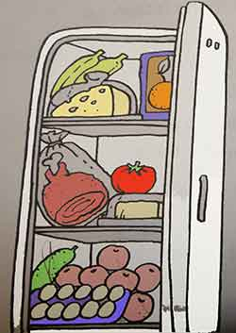

ТЕМА 1.7. УЧЕБНЫЙ ПРОЦЕСС В МЕДИЦИНСКОМ КОЛЛЕДЖЕ. ИМЯ ПРИЛАГАТЕЛЬНОЕ

Глоссарий:
to leave school – оканчивать школу
a first-year student – студент первокурсник
was founded – был основан
named after – назван в честь
the academic year – учебный год
terms – семестры
to wear a uniform – носить форму
a white gown – белый халат
a lunch break – обеденный перерыв
well-equipped – хорошо оснащены (оборудованы)
the maternity hospital – роддом
the ambulance department – отделение скорой помощи
the chemist’s – аптека
to follow a regular timetable – иметь постоянное расписание
humanities – гуманитарные дисциплины
natural sciences – естественные науки
hostel – общежитие
easy to get along with – хорошо ладить, легко общаться

- Прочитайте и переведите текст.
My name is Peter Ivanov. In June I left school and entered the medical college. Now I am a first-year student.
The Medical College was founded in 1930 and was named after L.A. Tarasevich. The college is situated in the central district of Tiraspol.
The academic year begins on the 1st of September. We have two terms and summer and winter holidays. Students of our college wear a uniform: a white gown. Our classes begin at 8.30 a.m. and usually finish at 2.30 p.m. We have a lunch break at 11.20 a.m. We have a good canteen and during our lunch period we take our meals there. There is a gym on the ground floor. Our library is on the ground floor too. It contains a lot of books on medicine, newspapers and magazines. Our classrooms and laboratories are large and light. Our labs are well-equipped. Every day we attend lectures and have practice. Senior students have practice outside the college: at the policlinic, at the maternity hospital, at the ambulance department, at the hospital, at the laboratories, at the chemist’s.
Students follow a regular timetable. There are many subjects in our timetable. We study humanities (Russian, English, Moldavian, History, Geography…); natural sciences (Biology, Chemistry, Microbiology); special sciences (Pediatrics, Surgery, Obstetrics and Gynecology and so on).
I do well because I want to be a good specialist. At the end of each term we pass exams. I’ll try to pass them successfully. Many students of our college live in the hostel. It is near our college.
We have classes 6 days a week. Sunday is a day off.
I like my college. I always feel at home there. Everybody is friendly and easy to get along with.
- Ответьте на вопросы.
1. When was the Medical College founded? What was it named after? 2. When does the academic year begin? 3. What kind of uniform do students wear? 4. When do classes begin and finish? 5. What is there on the ground floor? 6. What are laboratories? 7. Where do students have practice outside the College? 8. What subjects do students study? 9. What days of the week do students have classes?

- Прокомментируйте предложения следующим образом. Если предложение соответствует содержанию текста, скажите “It is right” и повторите предложение вслух. Если предложение неверно, скажите “It is wrong” и скажите правильный вариант.
1. The Medical College was founded in 1940 and was named after T.G. Shevchenko. 2. The academic year begins on the 2nd of September. 3. Students of our college wear a uniform: a white gown. 4. There is a gym on the first floor. 5. Our classrooms and laboratories are large and light. 6. At the end of each term we don’t pass exams. 7. We have classes 5 days a week.

- Расскажите о своём колледже.

- Подготовьте проект или презентацию о медицинском колледже.

Имя прилагательное.

- Образуйте сравнительную и превосходную степень следующих прилагательных. Не забывайте употреблять определенный артикль перед превосходной степенью прилагательных.
Hot, long, short, clever, silly, great, red, black, white, thin, thick, fat, nice, warm, cold, merry, small,
tall, high, weak, strong, heavy, light, green, dry, clean, dirty, wide, deep, brave.

- Переведите на английский язык.
Старый, старше, самый старый, самый старший, мой старший брат, мой старый друг, дальше,
самый дальний, самый длинный, короче, счастливый, счастливее, самый счастливый, самый
лучший, самый черный, длиннее, хуже, лучше, теплее, ее лучший друг, ее младший сын, его
старший сын.

ТЕМА 1.8. ПРОФЕССИЯ МЕДИЦИНСКОГО РАБОТНИКА. ИМЯ ПРИЛАГАТЕЛЬНОЕ

- Распределите названия профессий на две группы:
1) медицинские профессии
2) профессии, не имеющие отношение к медицине.
Architect, dentist, environmentalist, futurologist, gynecologist, hygienist, inventor, meteorologist, miner, neurologist, nurse, obstetrician, ophthalmologist, otolaryngologist, pediatrician, paleontologist, pathologist, physician, physicist, podiatrist, psychiatrist, radiologist, surgeon.
Medical
Non-medical
dentist
architect
……….
………

- Распределите следующие слова, которые встретятся в тексте «Профессия фельдшера», на 2 группы по частям речи: существительные (n) (7) и прилагательные (adj) (10).

Available, excellent, healthier, illness, impairment, important, irregular, longer, numerous, occupation, particular, quality, responsible, responsibility, thinker, tactful, treatment.

Словообразовательные суффиксы
Суффиксы глаголов v
Суффиксы прилагательных adj
Суффиксы существительных n
Суффиксы наречий
adv  -ate  -able /-ible  -age  -ly  -en  -al  -er / or  -ward  -fy  -ant /-ent  -ion  -ise /ize  -ar | -ist  -ary / -ory  -ity / ety  -ful  -ment  -ic  -ness  -ish  -sure  -ive  -ture  -less  ance/-ence  -ous  -y

- Просмотрите текст Doctor Assistant’s Occupation, определите содержание каждого абзаца, раскрывающего отдельную подтему. Для этого прежде всего проанализируйте начало абзаца. Запишите по-русски подзаголовки, соответствующие подтеме абзаца.

Doctor Assistant’s Occupation
1. Вступление. Описание работы фельдшера.
A physician, or a doctor assistant, is a professional who practices medicine. This includes maintaining or restoring human health through the study, diagnosis, and treatment of disease, injury, and other physical and mental impairments. Doctors work hard. They have many important responsibilities on their hands. Doctors work long hours, and they must be available on-call 24 hours a day. Seven days a week. A physician deals with numerous patients and every shift can be responsible for many things at once.
2._________________________________________________________________
The road to becoming a physician is long and difficult. Anyone who wants to become a doctor must understand that it takes much work to achieve that goal. At the very minimum, it takes several years to become a doctor, and longer for highly specialized medical fields. Still, most doctors love their work and believe it was well worth their years of effort.
3._________________________________________________________________
Some of the qualities of a good doctor are respect for people, support of patients and their families, courtesy, and communication skills. A physician must possess the skills necessary for his particular branch of medicine and should work with other members of the medical team. Doctors also must be excellent thinkers. They must be able to examine a sick person and figure out what is wrong. Then, they must be able to decide the best way to treat the patient’s illness or injury. Doctors must be emotionally balanced, patient, tactful and calm. Doctors must be able to communicate with patients directly and deliver both good and bad news in a clear, concise way. They must also be physically fit, since they often work long and irregular hours.
4._________________________________________________________________
A career in the medical field offers a wide range of specializations. Doctors can be specialists in delivering babies, treating kids, taking care of cardiac problems, handling emergencies, and so on. Every part of the human body is an area of specialization for doctors. From the hair on the head to the toes on the feet, for each problem there is a doctor who has specialized in its studies. No matter where they practice or what type of medicine they specialize in, doctors are important. Because of the work they do, people all over the world are able to live longer, healthier lives.

- Задание
А. Выпишите из текста слова с латинскими или греческими корнями, имеющие сходную форму в разных языках и нередко совпадающие по значению, - так называемые интернационализмы (15).
слово
произношение
значение
professional
Профессионал, специалист

Б. Прочитайте написанные слова, обратите внимание на особенности произношения и значения английских слов по сравнению с их русскими эквивалентами.
- В тексте Doctor Assistant’s Occupation встречается слово patient. Изучите словарную статью данного слова, приведённую ниже, и переведите следующие предложения со словом patient.

Patient
сущ.
1) больной, пациент
2) раненый
прил.
1) больной, терпящий страдания;
2) терпеливый, долготерпеливый.
A doctor deals with numerous patients.__________________________
A doctor examines the patient and figures out what is wrong._________
Doctors must be able to decide the best way to treat the patient’s illness or injury.___________________________________________________
Doctors must be emotionally balanced, patient, tactful and calm.

Имя прилагательное.

1. Переведите следующие предложения на английский язык.
1. а. Я знаю интересную историю.
б. Он знает более интересную историю.
в. Она знает самую интересную историю.
2. а. Это длинный путь.
б. Это более длинный путь.
в. Это самый длинный путь.
3. а. Ее работа очень важна.
б. Его работа важнее.
в. Моя работа самая важная.
4. а. Это плохая песня.
б. Это еще более плохая песня.
в. Это самая плохая песня.
5. а. Он хороший инженер.
б. Он более хороший инженер.
в. Он самый лучший инженер.
6. а. Он принес ей красивый цветок.
б. Он принес ей более красивый цветок.
в. Он принес ей самый красивый цветок.
7. а. Он рассказал нам о счастливом человеке.
б. Он рассказал нам о более счастливом человеке.
в. Он рассказал нам о самом счастливом человеке.

РАЗДЕЛ 2. АНАТОМИЯ ЧЕЛОВЕКА

ТЕМА 2.1. АНАТОМИЧЕСКОЕ СТРОЕНИЕ ТЕЛА ЧЕЛОВЕКА. ГЛАГОЛ TO BE В НАСТОЯЩЕМ ВРЕМЕНИ

Глоссарий:

the head – голова
the trunk – туловище
the limbs (extremities) – конечности
the skull – череп
the brain – мозг
the forehead – лоб
the cheeks – щёки
the chin – подбородок
the external ear – наружное ухо
the middle ear – среднее ухо
the internal ear – внутреннее ухо
the mouth – рот
gums – дёсна
a tongue – язык
a palate – нёбо
the neck – шея
the chest – грудь
the abdomen – живот
bones – кости
injury – травма
muscles – мышцы
the upper arm – верхняя часть руки
the forearm – предплечье
the elbow – локоть
the wrist – запястье
the hand – кисть руки
a thumb – большой палец руки
hip (the thigh) – бедро
the knee – колено
the calf – голень
the ankle – лодыжка
the skin – кожа
toe – палец ноги

1. Прочитайте и переведите текст. Покажите все части тела на картинке.
The principal parts of the human body are the head, the trunk, and the limbs (extremities). The upper extremities are arms, the lower extremities are legs.
The head consists of two parts: the skull which contains the brain, and the face which consists of the forehead, the eyes, the nose, the mouth with the lips, the cheeks, the ears, and the chin.
The ear includes three principal parts: the external ear, the middle ear, and the internal ear.
The mouth has two lips: an upper lip and a lower lip. In the mouth there are gums with teeth, a tongue and a palate.
The head is connected with the trunk by the neck. The upper part of the trunk is the chest and the lower part is the abdomen.
The framework of bones called the skeleton supports the soft parts and protects the organs from injury. The bones are covered with muscles.
The upper extremity is connected with the chest by the shoulder. Each arm consists of the upper arm,the forearm, the elbow, the wrist, and the hand. We have five fingers on each hand: a thumb, an index finger, a middle finger, a ring finger, and a little finger.
The lower extremity (the leg) consists of the hip (the thigh), the knee, the calf, the ankle, and the foot.The fingers of feet are called toes.
The body is covered with the skin.

2. Ответьте на вопросы по содержанию текста.
1. What are the principal parts of the human body?
2. What parts does the head consist of?
3. What parts does the ear include?
4. What are the upper part and the lower part of the trunk?
5. What do you know about the upper extremity?
6. What does the lower extremity consist of?
7. What is the body covered with?

3. Заполните пропуски словами из текста.
1. The upper … are arms, the lower … are legs.
2. In the mouth there are … with teeth, a tongue and a … .
3. The upper part of the trunk is the … and the lower part is the … .
4. We have five fingers on each hand ….
5. The body is covered with the … .

4. Подготовьте устную тему “Parts of human body” и покажите на тематическом стенде основные части тела человека.

Глагол to be в настоящем времени.

    - Вставьте глагол to be в Present Simple.
      - What…is your name? – My name…Shirley Frank. 2. What…your address? – My address… 175 Grand Central Parkway. 3. What …your phone number? –My phone number…718-1930. 4. Where …you from? –I …from New York. 5. I…a pupil. 6. My father…not a teacher, he…a scientist. 7.…your aunt a doctor?-Yes, she…. 8.…they at home?-No,they…not at home,they…at work. 9.My brother…a worker.He…at work. 10.…you an engineer?-No,I…not. I…a lawyer. 11. …your sister a typist? –No,she…not a typist, she…a student.

  - Переведите на английский язык, употребляя глагол to be в Present Simple.
    - Меня зовут Катя. 2. Мне 14 лет. 3.Я русская. Я из Санкт-Петербурга. 4. Я ученица. 5. Мой любимый вид спорта-теннис. 6. Я интересуюсь музыкой. 7. Мой любимый предмет-английский язык. 8. Мой папа-программист. Он не интересуется политикой. Его любимые виды спорта-футбол и плавание. 9. Моя мама-зубной врач. Она интересуется искусством. 10. Мы всегда заняты, но мы очень счастливы быть вместе.11. Чья это ручка?-Это моя ручка. 12. Чья это книга?-Это ваша книга.

ТЕМА 2.2. ВНУТРЕННИЕ ОРГАНЫ ТЕЛА. ГЛАГОЛ TO BE В ПРОШЕДШЕМ ВРЕМЕНИ

Глоссарий:

bladder – мочевой пузырь
brain – мозг
esophagus – пищевод
gallbladder – желчный пузырь
heart – сердце
intestines – кишечник
kidneys – почки
liver – печень
lungs – лёгкие
ovaries – яичники
pancreas – поджелудочная железа
spleen – селезенка
stomach – желудок
thyroid gland – щитовидная железа
uterus – матка
alimentary – пищеварительный

cecum – слепая кишка
junction – соединение
urine – моча
pelvic floor – диафрагма таза
pharynx – глотка
digestion – пищеварение
concave portion – вогнутая часть
fossa – впадина
to pump – качать
blood vessels – кровеносные сосуды
rhythmic contractions- ритмичные сокращения
urinary system – мочеполовая система
electrolytes – электролиты
acid-base balance – кислотный баланс
detoxification – детоксикация
bloodstream – кровоток
ovum – яйцеклетка
lateral wall of the pelvis – боковая стенка таза
to recycle iron – перерабатывать железо
fallopian tubes – маточные трубы
gestational period – гестационный период (период беременности)

1. Прочитайте и переведите текст. Выучите названия внутренних органов.
Human body is known as organism. Human body consists of various organ systems. Each organ
system performs a particular task.
Appendix
It is a blind-ended tube that is connected to the cecum. The appendix is located near the junction of the small and large intestines.
Bladder
In this organ, the urine that is filtered from the kidneys is collected before being disposed off by urination. The bladder is a muscular organ that is elastic in nature. It is located on the pelvic floor.
Brain
It is the most important organ of the human body, and it controls all the other parts. It is the center of the nervous system, and is the most complex of all internal organs. The brain controls our sense of vision, hearing, taste, smell, balance, and feeling.
Esophagus
It is a long muscular tube that passes from the pharynx into the stomach. This organ connects the
mouth to the stomach, and is about 25 to 30 cm long.
Gallbladder
It is one of the smallest internal organs of the human body. It helps in the process of digestion.
It is located in the concave portion of liver that iscalled the gallbladder fossa. The length of this portion is about 8 cm in adults.
Heart
After the brain, the heart is the second most important internal organ in humans. It is a muscular
organ whose main function is to pump oxygenated blood throughout the body through blood vessels. This action is carried out by repeated and rhythmic contractions. On an average, the human heart beats about 72 times per minute, and weighs 250 to 300 gm in females, and 300 to 350 gm in males.
Intestines
They are a segment of the alimentary canal, and they extend from the stomach to the anus. They are divided into: small intestine and the large intestine.
Kidneys
They serve as the most important part of the urinary system. Their function is regulation of electrolytes, maintenance of acid-base balance, regulation of blood pressure, production of urine, etc.
Liver
It is one of the most vital internal organs of the human body. The liver is an absolute necessity for survival. It carries out several functions including detoxification of blood, production of biochemicals for digestion, and protein synthesis.
Lungs
These organs are responsible for respiration. In humans, a pair of lungs is located in the chest on
either side of the heart. Their function is to transport atmospheric oxygen into bloodstream, and release carbon dioxide from blood into the atmosphere.
Ovaries
They are ovum-producing reproductive organs that are present in pairs in females. They are located in the lateral wall of the pelvis.
Pancreas
They belong to both the endocrine and digestive systems. These organs produce important hormones like insulin, glucagon, and somatostatin. They also produce pancreatic juice that contains digestive enzymes. If the pancreas do not function normally, it may lead to diabetes mellitus.
Spleen
The organ is very important with respect to the immune system. It is located in the left upper quadrant of the abdomen. Its function is to remove old red blood cells and also to recycle iron. The spleen in an adult human body is about 11 cm in length.
Stomach
The muscular, hollow bag in the alimentary canal is called the stomach. It is the primary organ of
the digestive system that is involved in the second phase of food digestion. The location of this organ is between the esophagus and small intestine.
Thyroid gland
The largest endocrine gland of the human body is the thyroid gland, which is located in the neck. It helps to control the use of energy in the body.
Uterus
It is the most important part of the female reproductive system. This organ is internally connected to the fallopian tubes on each side, and opens into the vagina at one end. In this organ the fetus develops during gestational period.
2. По описанию назовите внутренний орган и запишите на английском языке.

1) It is located in the left upper quadrant of the abdomen. Its function is to remove old red blood cells
and also to recycle iron.
2) In this organ the fetus develops during gestational period.
3) These organs produce important hormones like insulin, glucagon, and somatostatin.
4) These organs are responsible for respiration.
5) It is a muscular organ whose main function is to pump oxygenated blood throughout the body
through blood vessels.
6) It helps to control the use of energy in the body.
7) In this organ, the urine that is filtered from the kidneys is collected before being disposed off by
urination.
8) This organ connects the mouth to the stomach.
9) It is the primary organ of the digestive system that is involved in the second phase of food
digestion.
10) Their function is regulation of electrolytes, maintenance of acid-base balance, regulation of blood
pressure, production of urine, etc.

3. Дополните предложения пропущенными словами.
1) … is located near the junction of the small and large intestines.
2) … controls our sense of vision, hearing, taste, smell, balance, and feeling.
3) It is located in the concave portion of liver that is called the … .
4) It carries out several functions including … of blood, production of biochemicals for …, and
protein synthesis.
5) It is the primary organ of the digestive system that is involved in the second phase of … .

4. Выучите названия внутренних органов и покажите их на тематическом стенде.

Глагол to be в прошедшем времени.

      - Вставьте глагол to be в Past Simple.
My aunt…very depressed last Sunday. The weather …terrible. It..cold and rainy. Her husband…not at home. He…at hospital because he …sick. Her children…not at school. They…not in the yard, they…in the living room. The TV…broken. The children…not only upset, they…very angry. The neighbours… not happy because her children … too noisy.
The house… not clean. The sink…broken. There …dirty dishes on the kitchen table and in the sink. There…nothing in the fridge. There…no vegetables for dinner, there…no juice for her children. There…not even bread in the house. She… tired and hungry. She …just exhausted.

    - Переведите на английский язык, употребляя глаголы в Past Simple.
1. Я был болен вчера. 2. Она не была больна. 3. Мы были в кино. 4. Погода была прекрасная. Было тепло и солнечно. Мои дети были в школе, а мой муж был на работе. Я была в саду. Там было много красивых цветов. Это было весной. Я была счастлива.

ТЕМА 2.3. СКЕЛЕТ ЧЕЛОВЕКА. ГЛАГОЛ TO BE В БУДУЩЕМ ВРЕМЕНИ.

Глоссарий:
fused – соединенный
supplemented – подкреплённый
ligaments – связки
tendons – сухожилия
cartilage – хрящ
a scaffold – платформа
to anchor – укреплять
femur – бедренная кость
stapes – стремечко
pelvis – таз
cranium – череп
interconnected – взаимосвязаны
ossicles – косточки
articulate – соединять
hyoid bone – подъязычна кость
point of attachment – точка прикрепления

1. Прочитайте и переведите текст с помощью глоссария.
The human skeleton consists of both fused and individual bones supported and supplemented by ligaments, tendons, muscles and cartilage. It serves as a scaffold which supports organs, anchors muscles, and protects organs such as the brain, lungs and heart.
The biggest bone in the body is the femur and the smallest is the stapes bone in the middle ear. In an adult, the skeleton comprises around 14% of the total body weight, and half of this weight is water.
Fused bones include those of the pelvis and the cranium. Not all bones are interconnected directly: There are three bones in each middle ear called the ossicles that articulate only with each other. The hyoid bone, which is located in the neck and serves as the point of attachment for the tongue, does not articulate with any other bones in the body, being supported by muscles and ligaments.

2. Ответьте на вопросы по содержанию текста.
1. What does the human skeleton consist of?
2. What are the biggest and the smallest bones in the body?
3. What does the skeleton comprise in an adult?
4. What do fused bones include?
5. What is the name for three bones in middle ear?
6. What is the hyoid bone?

3. Найдите в тексте английские эквиваленты следующих русских слов и словосочетаний.
Соединенные кости, подкреплены связками, служит платформой, защищает органы, самая большая кость, бедренная кость, вес тела, взаимосвязаны напрямую, соединены друг с другом, гиоидная кость, служит точкой прикрепления.

4. Дополните предложения словами из текста.
1. It serves as a … which supports organs, … muscles, and protects organs such as the brain, lungs
and heart.
2. The biggest bone in the body is the … and the smallest is the … bone in the middle ear.
3. Not all bones are … directly.
4. The hyoid bone, which is located in the … and serves as the point of … for the tongue, does not
articulate with any other bones in the body, being supported by muscles and … .

5.Подготовьте устную тему “Human Skeleton”.

Глагол to be в будущем времени.

1. Переведите на английский язык, употребляя глагол to be в Future Simple.
1. Завтра они будут в театре. 2. Мой брат будет завтра дома. 3. Ты будешь дома завтра?4. Где он будет завтра? 4. Завтра в три часа Коля и Миша будут во дворе. 5. Завтра мой дедушка будет в деревне. 6. Когда твоя сестра будет дома? 7. Ты будешь летчиком? –Нет, я буду моряком. 8. Ты тоже будешь врачом?-Нет,я не буду врачом. Я буду инженером.

ТЕМА 2.4. КОСТИ СКЕЛЕТА. ГЛАГОЛ TO BE В РАЗНЫХ ВРЕМЕНАХ.

Глоссарий:
skull – череп
rib – ребро
vertebra – позвоночник
clavicle – ключица
scapula – лопатка
ulna – локтевая кость
radius – лучевая кость
humerus – плечевая кость
carpals, metacarpals, and phalanges – запястье, пясть, фаланги
pelvis – таз
femur – бедренная кость
tibia – большая берцовая кость
fibula – малоберцовая кость
patella – коленная чашечка
axial skeleton – осевой скелет
sternum – грудина
appendicular skeleton – добавочный
скелет
a joint – сустав
ligaments – связки
cartilage – хрящ

1.Прочитайте и переведите текст.
What is the skeleton? What does it do?
The skeleton is the entire collection of bones inside our body. The skeletal system is one of the major systems of the human body, and has four major functions:
1) It protects vital organs, such as the brain, heart, and lungs.
2) It supports the body and gives us our distinctive shape. Without our skeleton, we would look more like a slug.
3) It allows us to move in particular ways.
4) It makes new blood cells to maintain a healthy bloodstream.
With so many important jobs to do, the skeleton is a vital part of the human body.

Putting the pieces together
When humans are born they have around 350 bones. As they grow, some bones fuse together over time to form a single bone. As a result, adults have only 206 bones. The bones of the skeleton can be placed into two groups. The first group is called the axial skeleton, the bones that form our center. The bones of the axial skeleton support and protect the organs of the head, neck and trunk, including the skull, sternum, ribs, and vertebrae.
The second part of the human skeleton is called the appendicular skeleton. It is made up of all the bones related to our arms and legs (or appendages), including them bones of the arms, hands, legs, feet, shoulder, and hip. The place where two bones meet is called a joint.
There are two different types of joints: moving joints and fixed joints. In a fixed joint, the bones are fixed in place and do not move at all. The skull has many of these joints. Although it looks like one solid piece of bone, it is actually made up of 28 bones fused together with fixed joints. Moving joints allow a person to twist and bend. Bones are held together at the joints by stretchy bands of tissue called ligaments. In between the bones of a joint, there is a firm, rubbery tissue called cartilage.

Практические задания
1. Your approximate height can be measured from fingertip to fingertip when arms are stretched out
wide. Use a tape measure and have someone measure your height from fingertip to fingertip and then
from head to toe.
My arm span length: ____________________________________________________________
My height (head to toe): _________________________________________________________
Difference (if any): _____________________________________________________________
2. The biggest bone in the skeleton is the femur (thigh bone), which measures about 1/4 of a person’s
height. How long is your femur?
Length of my femur: ____________________________________________________________
My height divided by 4: __________________________________________________________
Difference (if any): _____________________________________________________________
3. About half your bones are in your hands and feet. If you have 206 bones, approximately how many bones are in your hands and feet?
Number of bones in my hands and feet: _____________________________________________
4. Your skeleton makes up about 1/5 of your total body weight. Approximately how much does your skeleton weigh?
My skeleton weighs: _______________________________________________

Глагол to be в разных временах.

- Вставьте глагол to be в Present Simple, Past Simple или Future Simple.
Ronald Wood…a managing director of the First Bank of Kongsville on main Street. He…always on a business trip. Yesterday he …in Geneva. Tomorrow he…in London. Last week he…in Chicago. Next week he… in New Orleans.At the moment he…in Amsterdam. In two hours he…in the Hague. Three days ago he…in Paris. At the end of his trip he…usually very tired but happy. He…with his family now. His sons…so much excited. They have got new toys from their father. Everybody in the family… very glad to see him at home again.

ТЕМА 2.5. ВИДЫ МЫШЦ И ТКАНЕЙ. ГЛАГОЛ TO HAVE В НАСТОЯЩЕМ ВРЕМЕНИ

1. Прочитайте и переведите текст.
Muscle is a contractile tissue (сокращающаяся ткань) and is derived from the mesodermal layer (мезодермальный слой) of embryonic cells. Muscle cells contain contractile filaments (нити) that move past each other and change the size of the cell. They are classified as skeletal, cardiac, or smooth (гладкие) muscles. Their function is to produce force and cause motion. There are three types of muscle tissue recognized in vertebrates (позвоночные):
Skeletal muscle or “voluntary muscle” (произвольно сокращающаяся мышца) is anchored
(закреплена) by tendons (сухожилия) to bone and is used to effect skeletal movement such as locomotion (передвижение) and in maintaining posture (осанка). Though this postural control is generally maintained as an unconscious (бессознательный) reflex, the muscles responsible react to conscious control like non-postural (непостуральный) muscles. An average adult male is made up of 42% of skeletal muscle and an average adult female is made up of 36%.
Smooth muscle or “involuntary muscle” is found within the walls of organs and structures such as the esophagus (пищевод), stomach, intestines, bronchi, uterus, urethra, bladder, blood vessels. Unlike skeletal muscle, smooth muscle is not under conscious control.
Cardiac muscle is also an “involuntary muscle” but is more akin (схожа) in structure to skeletal muscle, and is found only in the heart.

2. Ответьте на вопросы.
1. Give the definition of the word ‘muscle’.
2. What do muscle cells contain?
3. How are they classified?
4. What is a skeletal muscle?
5. What is a smooth muscle?
6. What is a cardiac muscle?

3. Составьте словосочетания, соединив слова в колонке A и B. Переведите их на русский язык.
A | B
Contractile | posture
cause | layer
mesodermal | vessels
unconscious | motion
anchored | tissue
maintaining | reflex
blood | by tendons

4. Дополните предложения пропущенными словами из текста.
1. Muscle cells contain contractile … that move past each other and change the size of the cell.
2. Skeletal muscle or “voluntary muscle” is anchored (закреплена) by … to bone and is used to effect skeletal movement such as … and in maintaining … .
3. An average adult male is made up of 42% of skeletal muscle and an average … is made up of 36%.
4. Smooth muscle or “involuntary muscle” is found within the walls of organs and structures such as
the esophagus, … , intestines, bronchi, …, urethra, bladder, blood … .
5. Cardiac muscle is also an “involuntary muscle” but is more … in structure to skeletal muscle, and
is found only in the … .

5. Назовите тип мышц в следующих органах.
1. Heart
2. Esophagus
3. Skeletal bone
4. Intestines
5. Bladder
6. Bronchi
7. Uterus
8. Stomach

Summarizing for memorizing
The Muscular System
There are more than 600 muscles in the Human Body!!!
Muscles are…
1) Needed for all types of movement
2) Needed to pump blood
3) Needed to breathe (diaphragm muscle)
4) Needed to produce body heat and regulate body temperature
5) Needed to protect internal organs.
There are 3 Types of Muscle
Skeletal Muscle:  Voluntary (under your conscious  control)  Movement of your bones, face,  eyes, etc. | Cardiac Muscle:  Involuntary (not under your  conscious control)  Movement of your heart and  certain blood vessels | Smooth Muscle:  Involuntary (not under your conscious control)  Movement of your intestines, esophagus, and other internal organs

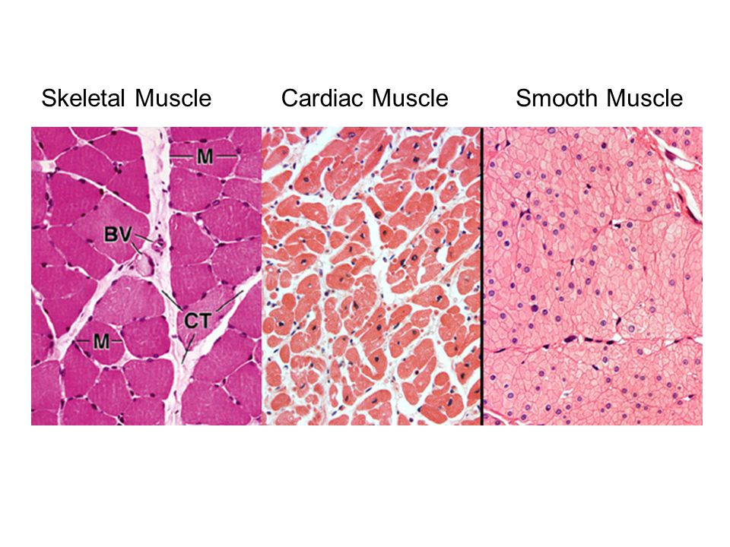
- Прочитайте и переведите текст.
A tissue is a group of cells that have a similar shape and function. Different types of tissues can be found in different organs. In humans, there are four basic types of tissue: epithelial, connective, muscular, and nervous tissue.
Epithelial tissue covers the body surface and forms the lining for most internal cavities. The major function of epithelial tissue includes protection, secretion, absorption, and filtration. The skin is an organ made up of epithelial tissue which protects the body from dirt, dust, bacteria and other microbes that may be harmful. Cells of the epithelial tissue have different shapes. Cells can be thin, flat to cubic to elongated.
Connective tissue is the most abundant and the most widely distributed of the tissues. Connective tissues perform a variety of functions including support and protection. The following tissues are found in the human body, ordinary loose connective tissue, fat tissue, dense fibrous tissue, cartilage, bone, blood, and lymph, which are all considered connective tissue.
There are three types of muscle tissue: skeletal, smooth, and cardiac. Skeletal muscle is a voluntary type of muscle tissue that is used in the contraction of skeletal parts. Smooth muscle is found in the walls of internal organs and blood vessels. It is an involuntary type. The cardiac muscle is found only in the walls of the heart and is involuntary in nature.
Nerve tissue is composed of specialized cells which not only receive stimuli but also conduct impulses to and from all parts of the body. Nerve cells or neurons are long and string-like.
Did you know you have more than 600 muscles in your body? They do everything from pumping blood throughout your body to helping you lift your heavy backpack. You control some of your muscles, while others — like your heart — do their jobs without you thinking about them at all.

Ответьте на вопросы:
Where can be found different types of tissues?
What are the three major types of muscles tissue in the body?
What is the muscle that pumps blood throughout your body?
How many muscles are there in your body?

Глагол to have в настоящем времени.
- Заполни пропуски глаголом have got/has got.
The child …a new beautiful toy.
They… eight beautiful flowers.
Ann…a nice black piano.
You…two beds in your room.
The woman…a very nice dress.
Tim…three bananas.
I…seven cousins.
Diana and George …four children.
Jane…two uncles.
We…five English books.

- Вставьте have или has.

…her parents got five sons?
…the dog got a puppy?
…Sue got friends?
…your sisters got toy elephants?
…the bird got corn?
…Ben got a new schoolbag?
…the table got four legs?
- Составьте вопросительные и отрицательные предложения.

- Mary has got a long green skirt.
- The dog has got a big bone.
- You have got a nice sister.
- My niece has got a husband.
- Henry and Mark have got a grandmother.
- Alice has got a father.
- The man has got a car.
- They have got three little dolls.
- I have got green apples.
- The cat has got a little fish.

ТЕМА 2.6. КРОВЬ И ЕЕ ЭЛЕМЕНТЫ. ГЛАГОЛ TO HAVE В ПРОШЕДШЕМ ВРЕМЕНИ

Глоссарий:
erythrocytes – эритроциты
leukocytes – лейкоциты
thrombocytes – тромбоциты
blood clotting – свертывание крови
release a protein – выпускать белок
fibrinogen – фибриноген
fibrin – фибрин
strings – струя
to form a clot – сформировать сгусток
nutrition – питание
a vein – вена
via finger prick – путем прокалывания
пальца
blood vessels – кровеносные сосуды
needle – игла
a body fluid – жидкость организма
the human body – человеческое тело
tissues – ткани
the removal of wastes – удаление отходов
oxygen – кислород
nutrients – питательные вещества
red (white) blood cells – красные (белые) кровяные
тельца
platelets – тромбоциты
hemophiliacs – больные гемофилией
сarbon dioxide – углекислый газ

1. Прочитайте и переведите текст, используя Глоссарий.
Blood is a body fluid that transports essential elements in the body. About eight percent of the human body weight is blood.
Blood has many functions, the two most important of which, is the transport of things to the tissues and the removal of wastes from the tissues. Blood transports oxygen to all the tissues of the body especially the ones in the brain. Hormones, nutrients like vitamins and minerals, and other body regulating elements are transported through the blood, too.
Blood is composed basically of red blood cells, white blood cells, platelets, and plasma. Nutrients, hormones, and waste products like carbon dioxide are also found in the blood. The red blood cells called erythrocytes carry oxygen.
The white blood cells or leukocytes are the soldier cells that fight infection. The platelets or thrombocytes are the smallest of the blood cells and are responsible for blood clotting.
When a wound bleeds, the platelets release a protein called fibrinogen which becomes fibrin. These turn into strings and weave together to form a clot and prevent more blood from spilling out of the body.
In the case of hemophiliacs, whose blood do not have platelets, having a wound can be very fatal. Plasma is basically water and this supplies the fluids in the cells. It is in the plasma where the nutrients, hormones and other elements are carried.
Blood composition slightly varies from person to person depending on nutrition, general well-being and the over all health of the organs. Various blood tests reveal how healthy or how sick an individual is.

2. Выберите правильный вариант согласно содержанию текста.
1) Which of the following statements is true concerning human blood?
a) The blood of all normal humans contains red and white cells, platelets, and plasma.
b) Some human populations normally lack the ability to produce plasma.
c) Proteins are not normal components of human blood.
2) Erythrocyte is another name for a:
a) red cell b) white cell c) platelet
3) Which of the following blood components provide the major defense for our bodies against invading bacteria and viruses?
a) red cells b) white cells c) platelets
4) The relatively clear liquid medium which carries the other cells of blood is called:
a) lipid b) antibody c) plasma
5) Which of the following are likely to increase in quantities when the body is under attack from bacteria?
a) erythrocytes b) leukocytes c) thrombocytes
6) When blood clumps or forms visible islands in the still liquid plasma, it is called:
a) clotting b) agglutination c) none of the above
7) Antigens are:
a) found on the surface of red cells
b) kinds of red cells that identify a blood type
c) relatively large carbohydrate molecules
d) a and b
8) Most of the volume of normal human blood is composed of:
a) red cells b) hemoglobin c) plasma d) white cells

3. Подготовьте презентации по темам «Сердце и кровь», «Работа сердца».

Глагол to have в прошедшем времени.

- Заполните пропуски соответствующей формой глагола to have в настоящем неопределенном или прошедшем неопределенном времени.
1.We usually … six lectures a week, but last week we…eight lectures. 2. Last winter was very cold. We …a lot of snow. 3. My brother…holidays in summer, but he… holidays in autumn last year. 4. They …a cottage in the country two years ago. 5. The tourists …a long journey. They were very tired. 6. Kate …a funny dog. Its name is Spot. 7. Their room is light. It…three windows. 8. I am happy because I…a lot of friends. 9. It was summer. I…a lot of free time. 10. Ann and Bess were at work yesterday. They… a lot of work. 11. Nick is a hunter. He…two dogs.

ТЕМА 2.7. СЕРДЦЕ. ГЛАГОЛ TO HAVE В БУДУЩЕМ ВРЕМЕНИ

Глоссарий:
to pump – качать
approximately – приблизительно
to remove the waste products – удалять
использованные продукты
cardiac cycle – сердечный цикл
cavity – полость
chambers – камеры
atria – предсердие
ventricle – желудочек
superior vena cava – верхняя полая вена
inferior vena cava – нижняя полая вена
coronary sinus – коронарный синус
right atrioventicular valve – правый предсердно-
желудочковый клапан
reoxygenated – перенасыщать кислородом
pulmonary veins – легочные вены
to nourish – питать
blood stream – кровоток
cardiac output – минутный объем сердца

- Прочитайте и переведите текст, используя Глоссарий.
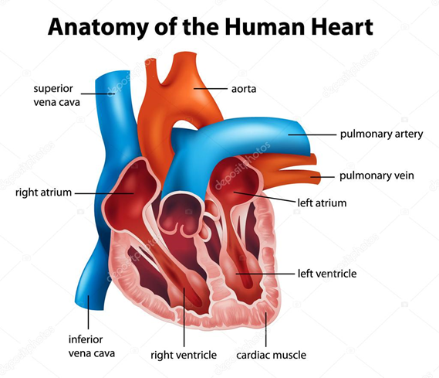
The heart is one of the most important organs in the human body. It pumps blood throughout the body, beating approximately 72 times per minute of our lives. The heart pumps the blood, which carries all the vital materials which help our bodies function and removes the waste products that we do not need.
The heart is a muscle. Like any other muscle in the human body, it contracts and expands. Each time the heart contracts it does so with all its force. In skeletal muscles, the principle of "gradation" is present. The pumping of the heart is called the Cardiac Cycle, which occurs about 72 times per minute. This means that each cycle lasts about eight-tenths of a second. During this cycle the entire heart actually rests for about four-tenths of a second.
Make-up of the Heart
The walls of the heart are made up of three layers, while the cavity is divided into four parts. There are two upper chambers, called the right and left atria, and two lower chambers, called the right and left ventricles. The Right Atrium, as it is called, receives blood from the upper and lower body through the superior vena cava and the inferior vena cava, and from the heart muscle itself through the coronary sinus.
The right atrium is the larger of the two atria, having very thin walls.
The right atrium opens into the right ventricle through the right atrioventicular valve. The right ventricle pumps the blood to the lungs to be reoxygenated. The left atrium receives blood from the lungs via the four pulmonary veins. It is smaller than the right atrium, but has thicker walls.
The left ventricle pumps the blood throughout the body. It is the Aorta, the largest artery in the body, which originates from the left ventricle.
The Heart works as a pump moving blood around in our bodies to nourish every cell.
Blood that has been reoxygenated by the lungs is drawn into the left side of the heart and then pumped into the blood stream. It is the atria that draw the blood from the lungs and body, and the ventricles that pump it to the lungs and body. The output of each ventricle per beat is about 70 ml, or about 2 tablespoons. In a trained athlete this amount is about double. With the average heart rate of 72 beats per minute the heart will pump about 5 litres per ventricle, or about 10 litres total per minute. This is called the cardiac output.

- Напишите части сердца на английском языке.
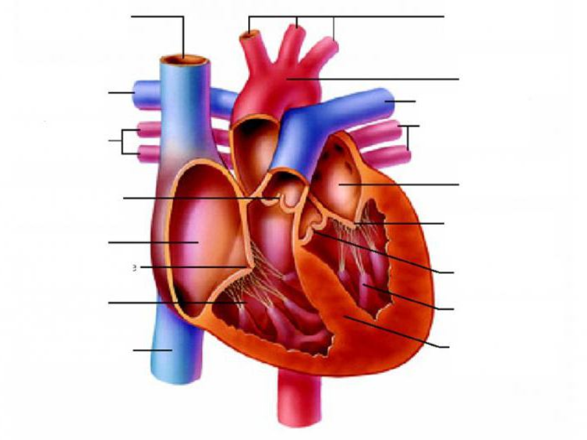
Глагол to have в будущем времени.

- Заполните пропуски соответствующей формой глагола to have в будущем времени.
- John … two hamsters .
- Richards parents ... a white car.
- Helen and Mike…many friends.
- My cousin … many English books.
- We…not…French on Monday.
- They … a lot of flowers.

ТЕМА 2.8. ДЫХАТЕЛЬНАЯ СИСТЕМА. THE PRESENT SIMPLE TENSE

Глоссарий:
pharynx – глотка
larynx – гортань
trachea – трахея
bronchi – бронхи
bronchiole – бронхиола
alveoli – альвеола
lungs – легкие
entrance – вход
to humidify – увлажнять
esophagus – пищевод
vocal cords – голосовые связки
diverging – расходящиеся
sac – мешочек, киста
elastic fibers – эластичные волокна
inverted-cone – конусообразный
carbon dioxide – углекислый газ
oxygen – кислород
breathing – дыхание
swallowing – глотание
tubelike – трубкообразный

- Прочитайте и переведите текст.

The respiratory system is divided into two parts: the upper respiratory tract and the lower respiratory tract. The following are the organs of the upper and the lower respiratory tract.
The Upper Respiratory Tract Nose. It is the entrance of the respiratory tract and helps in allowing air to flow in and out. It humidifies, warms, and filters the air that comes in.
Pharynx (throat). It is located at the back of the mouth, and connects the mouth to the esophagus (food pipe). It is a passage for air and food.
Larynx. It is present at the top of trachea and contains vocal cords. It is also known as the voice box.
It helps in controlling breathing and swallowing.
Trachea (windpipe). It is a tubelike structure that helps in passing air from larynx to bronchi. It also warms the air and prevents foreign bodies from entering lungs.
The Lower Respiratory Tract Bronchi. These are the airways of the lungs diverging from the trachea. They carry air in and out of the lungs.
Bronchioles. These are branches of the bronchi that conduct air into the lungs. They perform the same function as the bronchi.
Alveoli. These are sacs in the lungs and contain elastic fibers. The exchange of carbon dioxide and oxygen occurs here.
Lungs. These are the two inverted-cone shaped organs present in the chest of human beings. The function of lungs is to take in oxygen into the body and expel carbon dioxide.

- Изучите диаграмму респираторного тракта (см. рис. далее).
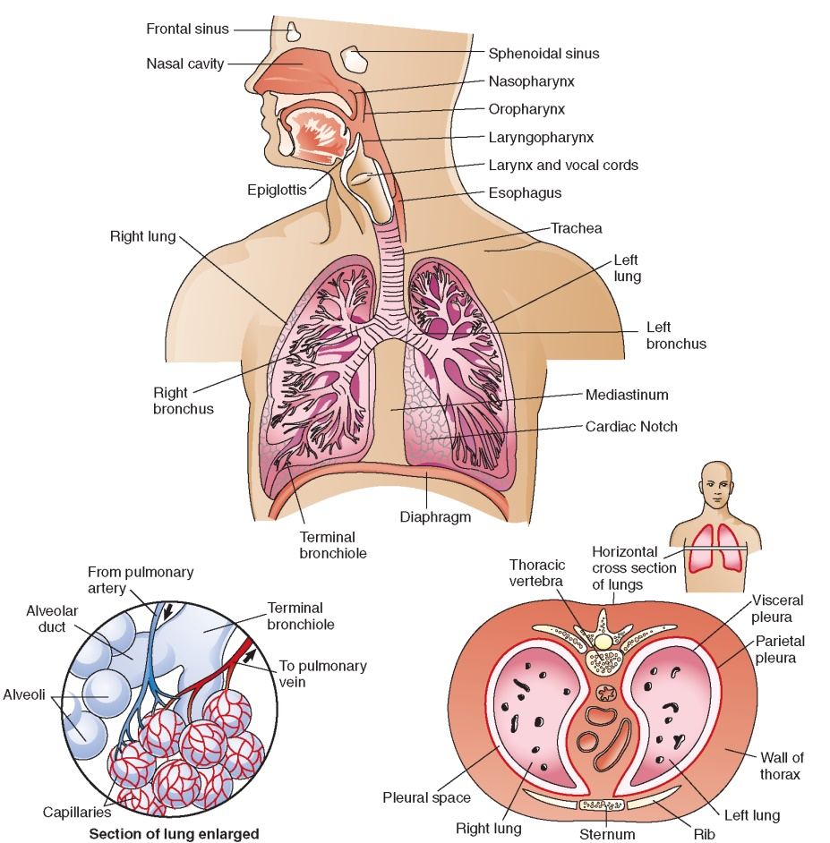

3. Соотнесите названия с определениями.

a) is a tubelike structure that helps in passing air from larynx to bronchi.
b) is the entrance of the respiratory tract and helps in allowing air to flow in and out.
c) is located at the back of the mouth, and connects the mouth to the esophagus.
d) are the two inverted-cone shaped organs present in the chest of human beings.
e) are branches of the bronchi that conduct air into the lungs.
f) are sacs in the lungs and contain elastic fibers.
g) is present at the top of trachea and contains vocal cords.
h) are the airways of the lungs diverging from the trachea.
1) Bronchi 5) Bronchioles
2) Alveoli 6) Nose
3) Larynx 7) Trachea
4) Pharynx 8) Lungs

4. Напишите части респираторной системы человека на английском языке.
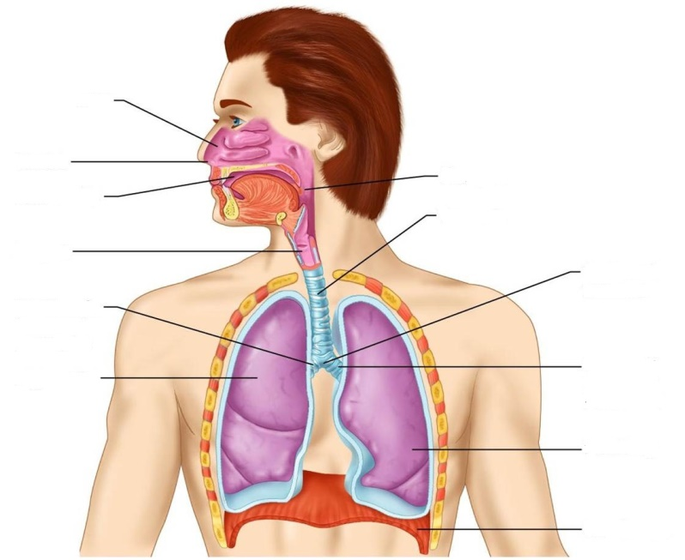
5. Прочитайте и переведите текст о болезнях, вызванных курением.

CAUSES OF SOME DISEASES
Cigarette smoking
This is a harmful habit which reduces the expectation of good health and shortens life. Cigarette smokers absorb into the lungs:
1. Nicotine. This is a habit-forming drug with a mild stimulatory effect. It causes construction of small blood vessels and a rise in blood pressure.
2. Carcinogenic tars. These tars isolated from cigarette smoke have been shown to cause cancer in experimental animals.
3. Carbon monoxide. Cigarette smokers have raised blood levels of carboxyhaemoglobin passes through into the fetal circulation.
The following ailments are prone to occur in cigarette smokers:
Cancer of the lung. Heavy cigarette smokers are 30 times as liable to develop cancer of the lung as non-smokers are. There is overwhelming evidence that lung cancer is caused by cigarette smoking.

6. Подготовьте мини проекты на тему “Smoking is a dangerous bad habit”.

The Present Simple Tense.

1. Раскройте скобки, употребляя глаголы в Present Simple.
1. Alice (to have) a sister.
2. Ann (to be) a student.
3. She (to get) up at seven o’clock.
4. She (to go) to the institute in the morning.
5. She (to do) her morning exercises every day.
6. For breakfast she (to have) two eggs, a sandwich and a cup of tea.
7. After breakfast she (to go) to the institute.
8. Sometimes she (to take) a bus.
9. She (to speak) English well.
10. She (to go) to bed at 11 p.m.
2. Раскройте скобки, употребляя глаголы в Present Simple.
1. My working day (to begin) at six o’clock.
2. I (to get) up, (to switch) on the TV and (to brush) my teeth.
3. It (to take) me about twenty minutes.
4. I (to have) breakfast at seven o’clock.
5. I (to leave) home at half past seven.
6. I (to take) a bus to the institute.
7. It usually (to take) me about fifteen minutes to get there.
8. Classes (to begin) at eight.
9. We usually (to have) four classes a day.
10. I (to have) lunch at about 2 o’clock.

3. Составьте предложения из следующих словосочетаний.
1. The 8th in Sochi I on was born July of.
2. My collection CD discs I many in have.
3. I on TV often Discovery and Science watch channels.
4. Read art and science a lot of I books on.

4. Поставьте глаголы в следующих предложениях в утвердительную, вопросительную и отрицательную формы Present Simple.
1. I (to do) morning exercises.
2. He (to work) at a factory.
3. She (to sleep) after dinner.
4. We (to work) part-time.
5. They (to drink) tea every day.
6. Mike (to be) a student.
7. Helen (to have) a car.
8. You (to be) a good friend.
9. You (to be) good friends.
10. It (to be) difficult to remember everything.

ТЕМА 2.9. ПИЩЕВАРИТЕЛЬНАЯ СИСТЕМА. THE PRESENT CONTINUOUS TENSE

Глоссарий:
digestive system – пищеварительная система
conversion of food – превращение пищи
mouth – рот
esophagus – пищевод
stomach – желудок
small and large intestines – большой и малый
кишечник
salivary glands – слюнные железы
liver – печень
gall bladder – желчный пузырь
pancreas – поджелудочная железа
to secrete – выделять
absorbed – поглощенный
to separate – отделять, разделять
to dispose – размещать
waste products – отходы
to ingest – проглатывать
oral cavity – ротовая полость
tongue – язык
pharynx – глотка
dilated – расширенный
acid – кислота
indigestible – непереносимый
ejection – выброс
expulsion of feces – испражнение фекалий
bile – желчь
emulsification – образование эмульсии
chewing – жевание
rolling and lubrication – раскатывание и смазывание

1. Прочитайте и переведите текст, используя Глоссарий.
The digestive system is a group of organs responsible for the conversion of food into nutrients and energy needed by the body. In humans, the digestive system consists of the mouth, esophagus, stomach, and small and large intestines. The digestive tube made up by these organs is known as the alimentary canal.
Several glands — salivary glands, liver, gall bladder, and pancreas — also play a part in digestion. These glands secrete digestive juices containing enzymes that break down the food chemically into smaller molecules that are more easily absorbed by the body. The digestive system also separates and disposes of waste products ingested with the food.

Digestive System Outline

Components | Necessary organs  Oral cavity  It is the cavity of mouth, irregular in shape, contains tongue, teeth and salivary glands.  Esophagus  Muscular tube passing the food from pharynx to stomach.  Stomach  Muscular, hollow and dilated part of alimentary canal, involved in both mechanical and chemical digestion of food, secretes strong acid and enzymes to aid in digestion of food.  Small Intestine  Lies between stomach and large intestine, majority of digestion and absorption takes place here.  About 5 meters in length.  Large Intestine  Second-to-last part of alimentary canal, main function is to absorb water from indigestible food.  Anus  Last part of alimentary canal, opens to outside for ejection of food. Controls the expulsion of  feces.  Accessory Organs  Liver  Produces bile for emulsification of fats.  Pancreas  Secretes pancreatic juice containing different digestive enzymes into the small intestine.  Teeth  Chewing of food.  Tongue  Rolling and lubrication of food.
Functions | Digestion and absorption of food

- Изучите диаграмму пищеварительной системы.

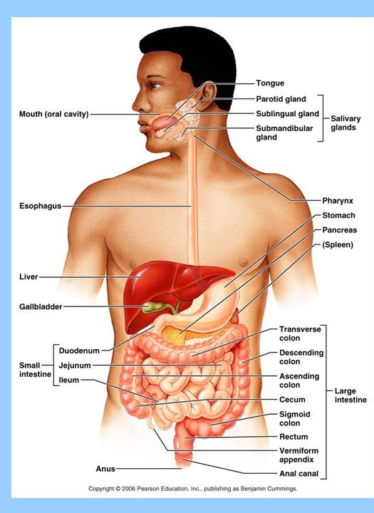

3. Определите орган пищеварительной системы по определению.
a) controls the expulsion of feces.
b) absorbs water from indigestible food.
c) are used for chewing food.
d) passes the food from pharynx to stomach.
e) contains tongue, teeth and salivary glands.
f) secretes pancreatic juice containing different digestive enzymes into the small intestine.
g) produces bile for emulsification of fats.
h) muscular, hollow and dilated part of alimentary canal.
i) majority of digestion and absorption takes place here.

4. Напишите органы пищеварительной системы.

The Present Continuous Tense.

1. Раскройте скобки, употребляя глаголы в Present Continuous (NOW)
1. My book (to lie) on the table.
2. They (to work).
3. The doctor and her patient (to talk).
4. We (to cook) dinner. My mother (to make) a salad.
5. A young man (to drive) a car. He (to listen) music.
6. My grandfather (to read) a book.
7. The pen (to lie) on the floor.
8. You (to have) a break?
9. She still (to sing).

2. Раскройте скобки, употребляя глагол в форме Present Simple или Present Continuous.

It’s 5.30 a.m. Suzanne Wells is in her kitchen at home. She (to have) breakfast at this time every morning. She (to leave) home at 8.30 a.m. every day and (to go) to work. Suzanne is a teacher. She (to work) at a school in Canberra. It’s 10.00 a.m. now and Suzanne is at school. At the moment she (to teach) her class of 8-year-old children. All the children in her class (to come) from Canberra. She (to teach) English to the class now. The pupils (to pronounce) new words at the moment.

3. Образуйте вопросы, используя времена Present Simple или Present Continuous. Дайте ответы.
1) you | often | wear | jeans?
2) you | wear | jeans now?
3) it | rain | now?
4) it | often | rain | in your country?
5) you | study | English every day?
6) you | study | English at the moment?
Example: Do you often wear jeans? — Yes, I do.

РАЗДЕЛ 3. ИСТОРИЯ МЕДИЦИНЫ

ТЕМА 3.1. ИСТОРИЯ МЕДИЦИНЫ. THE PRESENT PERFECT TENSE

1. Прочитайте и переведите текст.

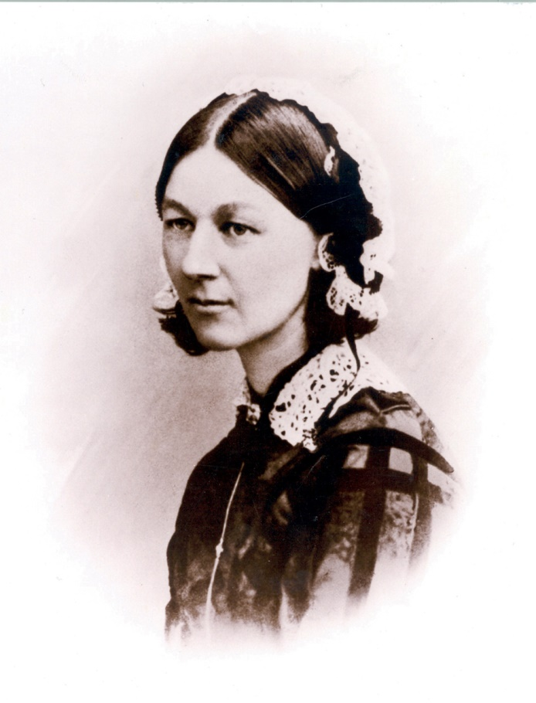
Florence Nightingale
День рождения: 12.05.1820 г.
Место рождения: Флоренция, Великобритания
Дата смерти: 13.08.1910 года
Место смерти: Лондон, Великобритания
Гражданство: Великобритания

Before the 1850s nursing in England was classed with the lowest kind of work. Women who worked in public hospitals were regarded as rough, ignorant and dirty. Florence Nightingale was brought up in a wealthy family. In those days girls like her were expected to marry well and produce children. Florence’s parents were horrified when she told them that she wanted to become a professional nurse and she went abroad. She spent three months in Germany and a short time in Paris observing their methods.To gather information about hospital administration she devoted a lot of time writing to institutions in various European countries. In 1853 she took over the administration of a women’s hospital in London and reorganized it with great success. The following year England went to war with Russia.
Florence Nightingale was asked to help and in the autumn of 1854 she sailed for the Crimea with a party of 38 other nurses. The hospital was a crumbling old building. Many were lying on the bloodstained floors because there were not enough beds. There was a shortage of everything including bandages, medicine, blankets, even soap and the wards were rat-infested-there was filth everywhere.
Together with her team she set to work. Her nurses scrubbed the wards, corridors and lavatories. She reorganized the kitchens and set up a laundry. For months she worked up to twenty hours a day, ending each day by visiting the wounded soldiers, carrying a lamp in her hand. Queen Victoria offered her a reward for the work she had done. Instead Florence Nightingale asked people to give money to set up schools to train nurses. The money poured in. In 1860 a nursing school was opened in London and similar training schools were soon set up in other places.
The student nurses were carefully chosen. They had to be literate, honest, hard working and willing to live under strict discipline. Even their personal diaries were regularly inspected to see how they were behaving themselves. Florence Nightingale opened up a whole new field of work for women. By 1900 Britain had 64,000 skilled nurses, ensuring that their hospitals were efficient and hygienic. Florence Nightingale lived to the age of 90 and died in 1910.

2. Выберите правильный ответ.
1) Florence Nightingale was:
a) an English nurse; b) a Russian nurse; c) a French nurse; d) a Turkish nurse.
2) Florence was born in:
a) autumn; b) winter; c) spring; d) summer.
3) Florence was called:
a) the lady with the clock; c) the lady with the flowers;
b) the lady with the lamp; d) the lady with the chair.
4) She studied the method of:
a) jumping; b) nursing; c) teaching children; d) swimming.
5) She worked in:
a) hospitals; b) shops; c) schools; d) offices.
6) In 1854 she worked in the hospital in London in:
a) Oxford Street; b) Fleet Street; c) Westminster; d) Harley Street.
7) In 1854 Florence went to the Crimean War together with:
a) 10; b) 100; c) 50; d) 38 nurses to help soldiers get better.
8) In 1860 she opened a school for nurses at St. Thomas’ hospital in:
a) Paris; b) London; c) Moscow; d) St. Petersburg.
9) Florence got the King’s Red Crist in:
a) 1883; b) 1903; c) 1803; d) 2013.
10) She was in Britain:
a) the first; c) the third;
b) the second; d) the fourth woman to be awarded the Order of Merit in 1907.
11) She died in:
a) 1920; b) 1910; c) 1935; d) 1905 at the age of 90.

The Present Perfect Tense

1. Заполните письмо Джейн глаголами в Present Perfect.
Dear Amy,
I _____ (not have) a letter from you for a long time. _____ (you lose) my address? I bought the new
Steps CD at the weekend. I _____ (already listen) to it. _____ (you hear) it yet? It’s brilliant. There’s a
new video too, but I _____ (not see) it yet. School is going OK. I _____ (just finish) some exams, but
the holidays _____ (not start) yet. We’re going to Ireland. I _____ (never be) there. Write soon with your
news.
Love Jane

2. Раскройте скобки, употребляя глаголы в Past Simple или Present Perfect.
1. I ________ (never/ be) to the USA. I ______ (want) to go there last summer but I couldn’t.
2. He _______ (live) in this street all his life. 3. His father ________ (come back) to London last Sunday.
4. Yan __________ (write) a letter to Nick two days ago. 5. He ________ (send) his letter yesterday.
6. They ________ (just/ buy) some postcards.

ТЕМА 3.2. УЧЕНЫЕ-МЕДИКИ И ИХ ВКЛАД В МЕДИЦИНУ. THE PRESENT PERFECT TENSE

Глоссарий
faculty– факультет
Crimea -Крым
direction – руководство
model – образец
equip– оборудовать
diagnostician – диагност
achievement – достижение
scientist – ученый
excellent – превосходный
therapeutics – терапия
physician – врач
Medical faculty –медицински факультет
brilliant scientist–блестящи ученый
under the direction – под руководством
famous names – знаменитые имена
surgeon – хирург
greatest achievements – великие достижения
military therapeutics – военная терапия
well-equipped – хорошо оснащенный
medical aid – медицинская помощь

Sergey Petrovich Botkin

S.P. Botkin was born on September 17, 1832. After finishing one of Moscow schools, he entered the Medical Faculty of Moscow University.
S.P. Botkin was interested in medicine very much and soon became one of the best students.
After graduating from the Medical Faculty in 1855 S.P. Botkin went to the Crimea where he worked as a physician at the Simferopol Military Hospital under the direction of the well-known Russian surgeon Pirogov.
In 1860 S.P. Botkin began to work at the Medico-Surgical Academy in Petersburg. In 1861 he became a professor of the Therapeutic Clinic at the Academy. He worked hard. He wanted to have a model clinic at the Academy. S.P. Botkin organized a well-equipped physiological laboratory for clinical experiments. S.P. Botkin was a brilliant
therapeutist and diagnostician. One of his greatest achievements was his theory of neurosis, which is the most progressive theory in clinical medicine.
S.P. Botkin was not only a brilliant scientist but an excellent teacher too. Many of his pupils became famous physician and worked at Russian universities as professors.
S.P. Botkin was also one of the founders of military therapeutics. He worked at the front during the Russo-Turkish war giving much of time to the organization of medical aid.
During his whole life he never stopped working for the good of the Russian people. His name is one of the most famous names in medicine and it will be always remembered in the history.

The Present Perfect Tense

- Прочитайте и переведите предложения.
I have cleaned my coat. – It is clean now.
I have finished my homework. – I may go for a walk.
I have read the book. – I can give it to you.
The rain has stopped. – The weather is fine.
Pete has come. – You may speak to him.
Who has illustrated this book?
The train has already left. We have been there already and don`t want to go again.
Have you ever been to the South? No, never.

2. Выберите нужную временную форму глагола.

1.I (have seen, saw) the doctor. I (have seen, saw) him two hours ago. 2. My friend (has been, was) there last winter. 3. The post man (has brought, brought) a letter for you. He (has brought, brought) the letter half an hour ago. 4. We (have lived, lived) in Brest in 1978. He (has lived, lived) in that village. 5. My brother (has caught cold, caught) and he stays in bed. 6. Mike (has missed, missed) two days. He (has missed, missed) two days last week.

